Lab 1

Nikita Dhingra

# Table of Contents

Table of Contents 2

Lab 1 3

Description 3

Preparation 3

Observations 3

Screenshots 3

Reflection 3

References 3

# Lab 1

## Description

In order to connect the application, which has been running locally on VSphere, to the database on AWS using a third-party tool, there are a total of four tasks that will be completed in this lab activity to show how to integrate installed systems locally with databases that are hosted in the cloud (AWS).

## Preparation

The lab activity and steps were explained very well in the document and these were some of the steps:

We built a Windows 10 virtual machine on vSphere for this project, set up XAMPP. Also installed: MySQL workbench and as well, and then connected MySQL Workbench to an RDS database that was set up on AWS. Additionally, we added the new data in the tables for operations, hospital, patients, and doctors were displayed correctly in MySQL Workbench after importing the hospital (rk_hospital).

## Observations

We observed that in AWS RDS under the connectivity , we should chose the option of making RDS publicly accessible otherwise mySQL Workbench won’t be able to host connection to the endpoint. Moreover there were little bit other minor errors which need careful observation.

## Screenshots

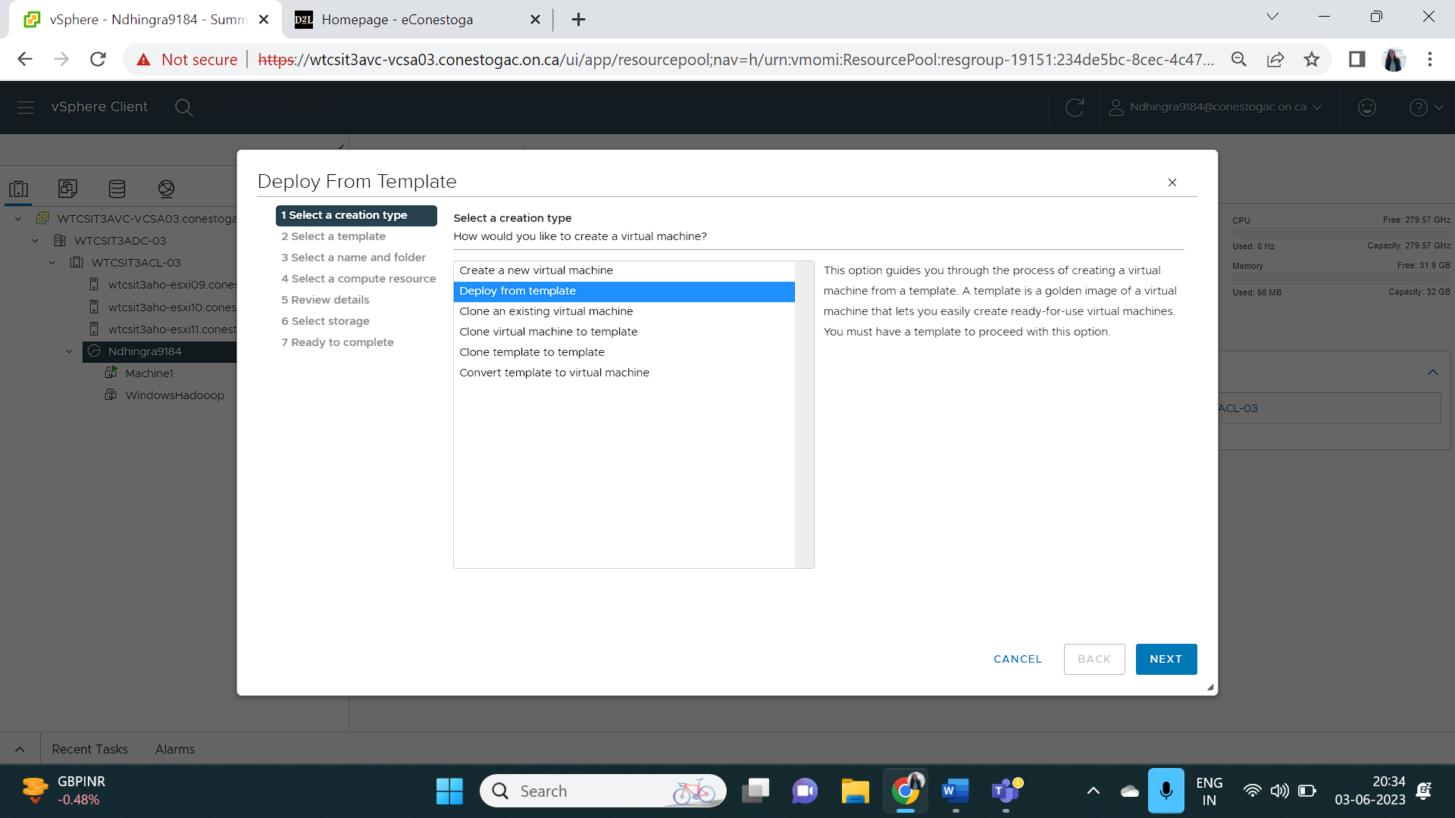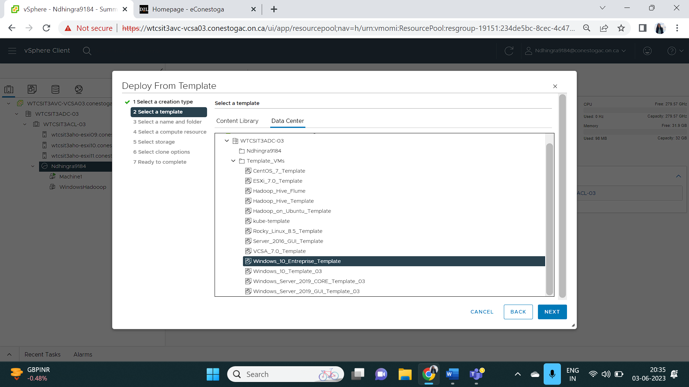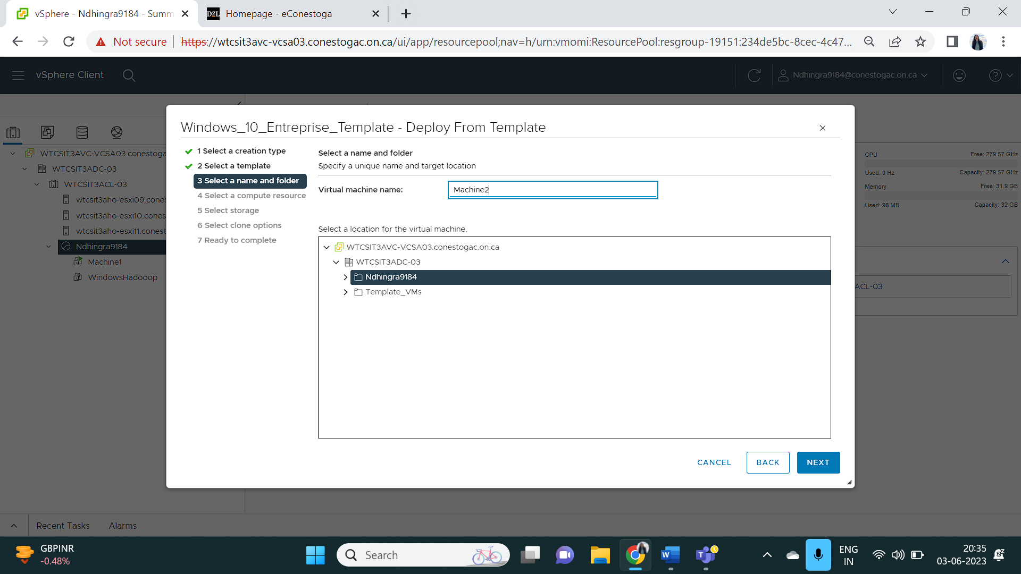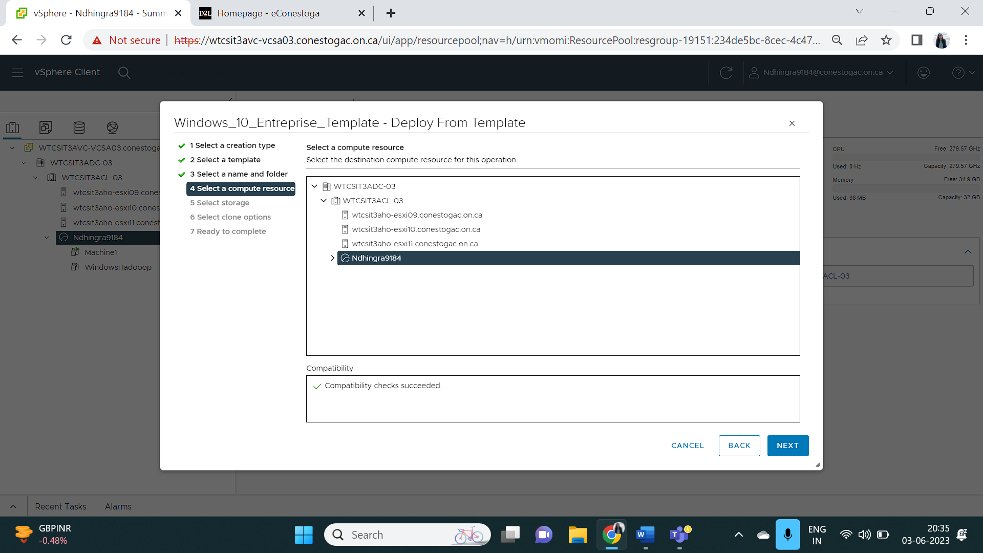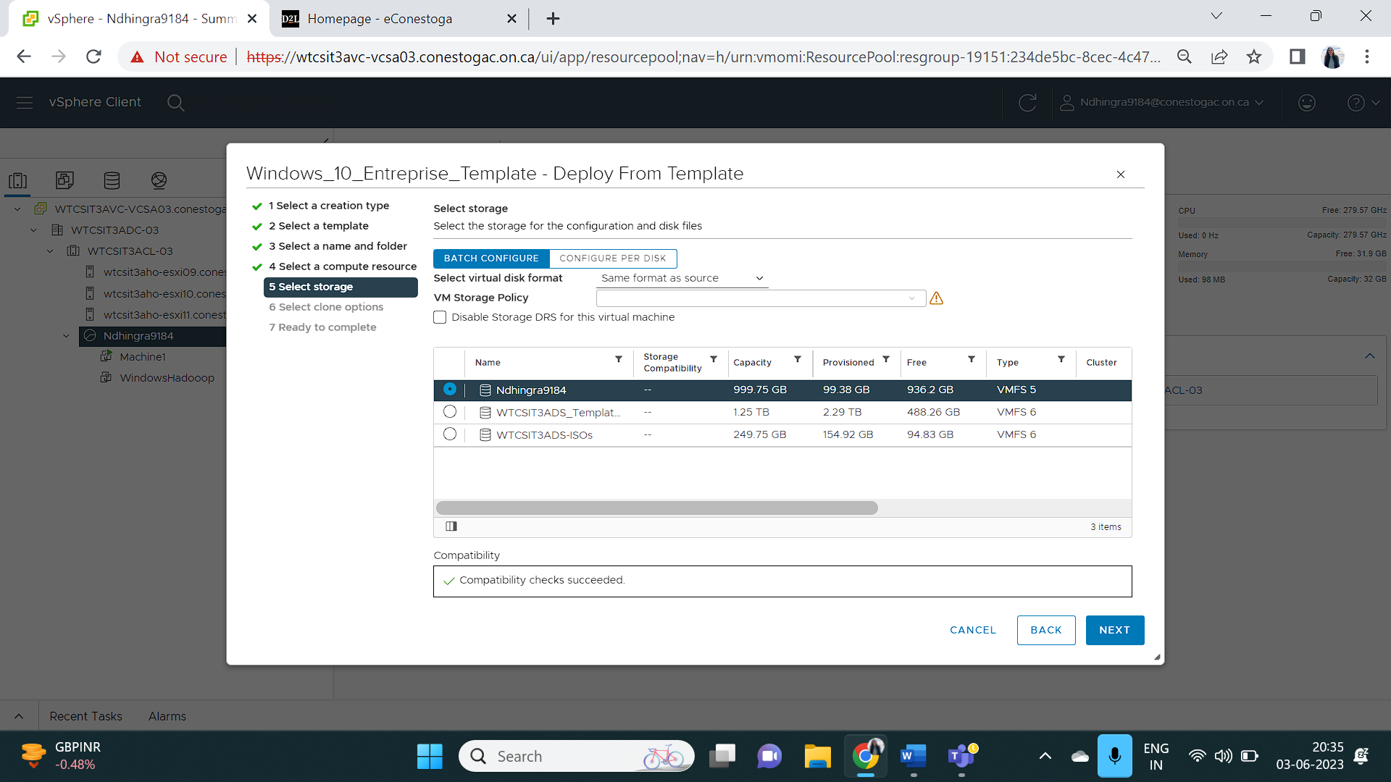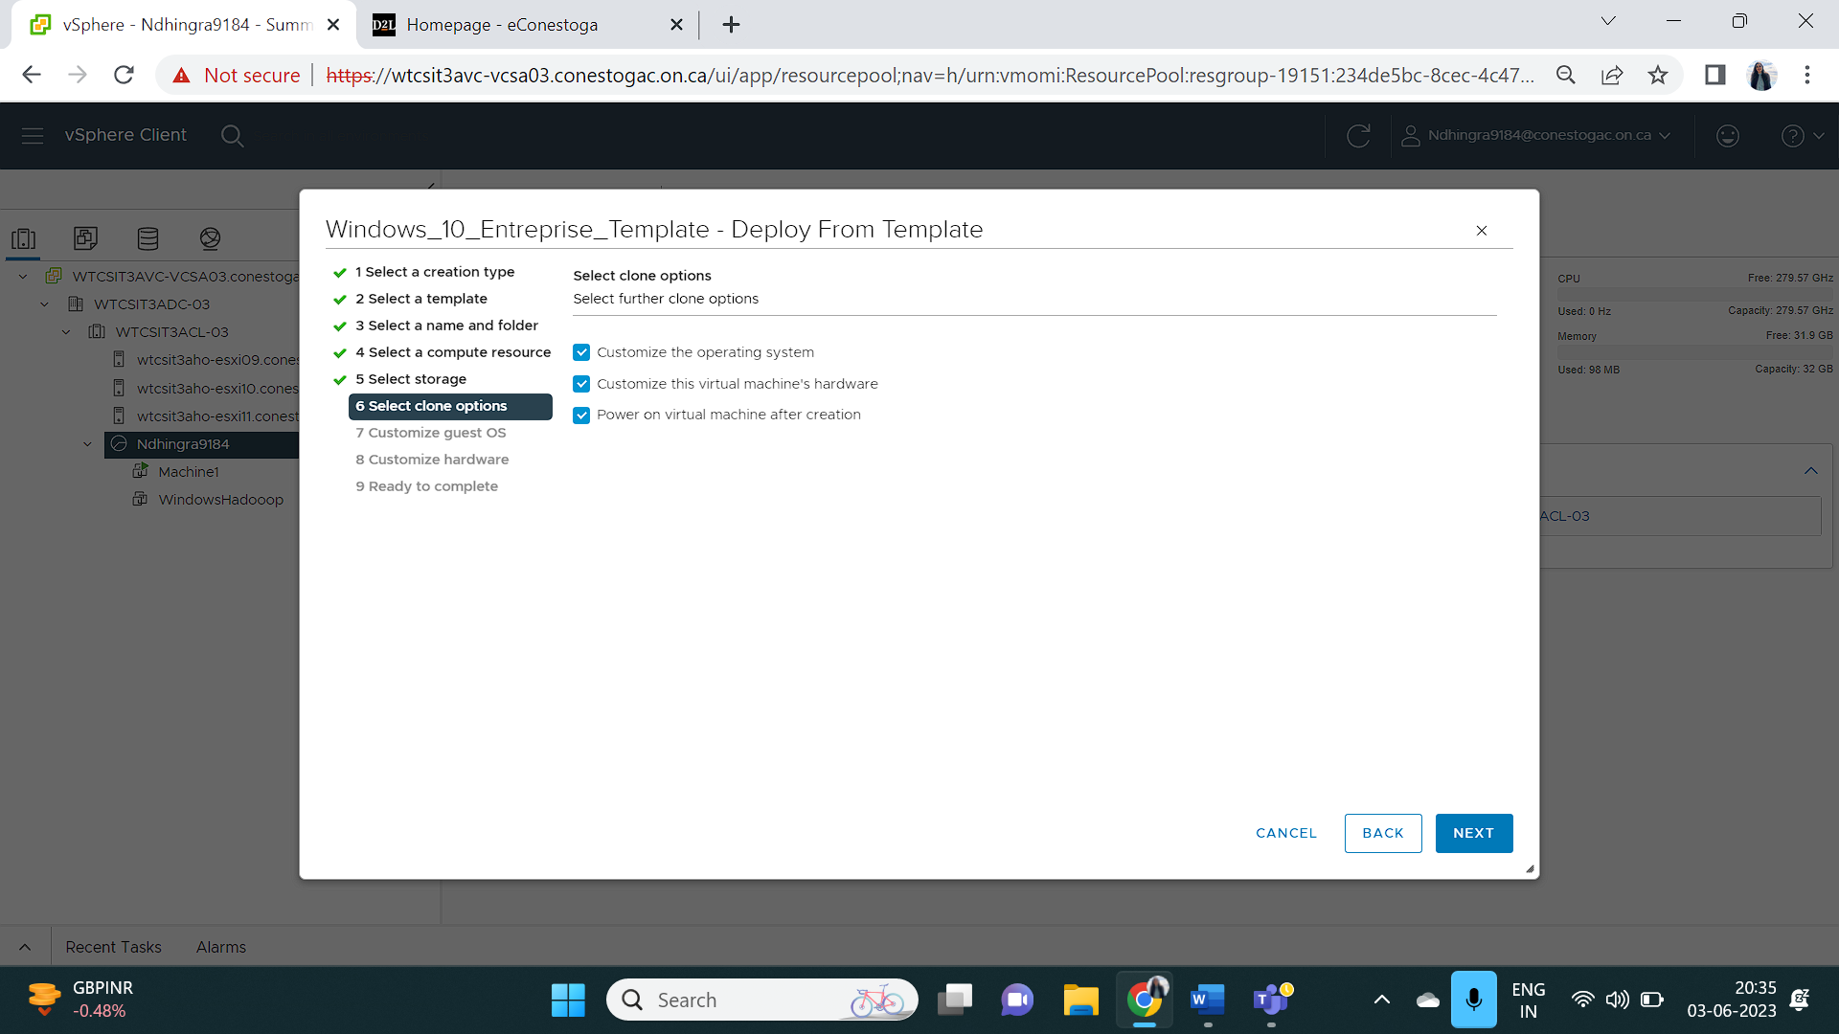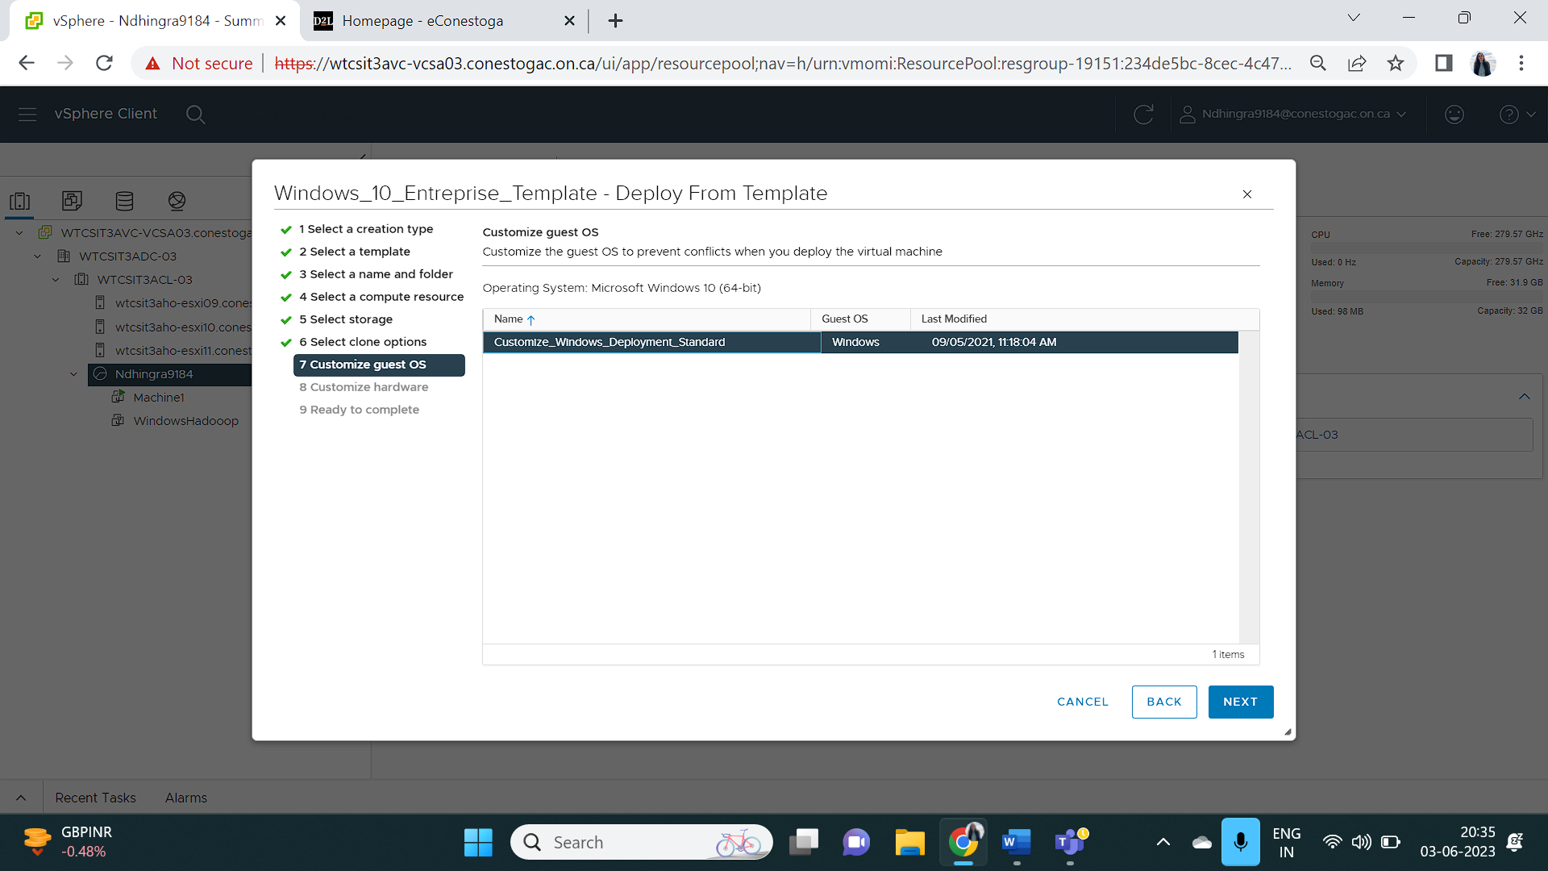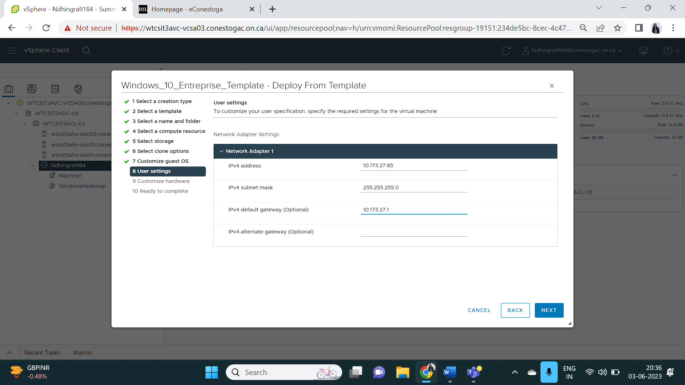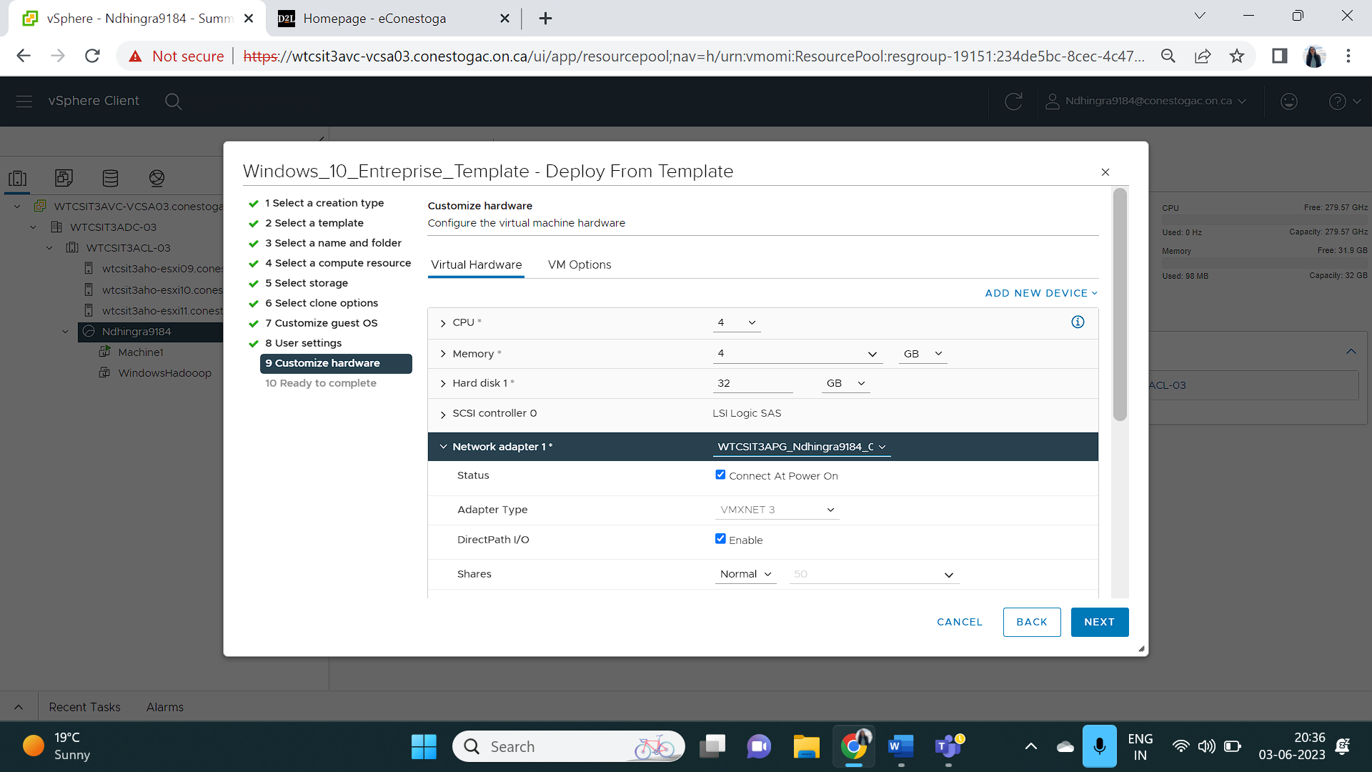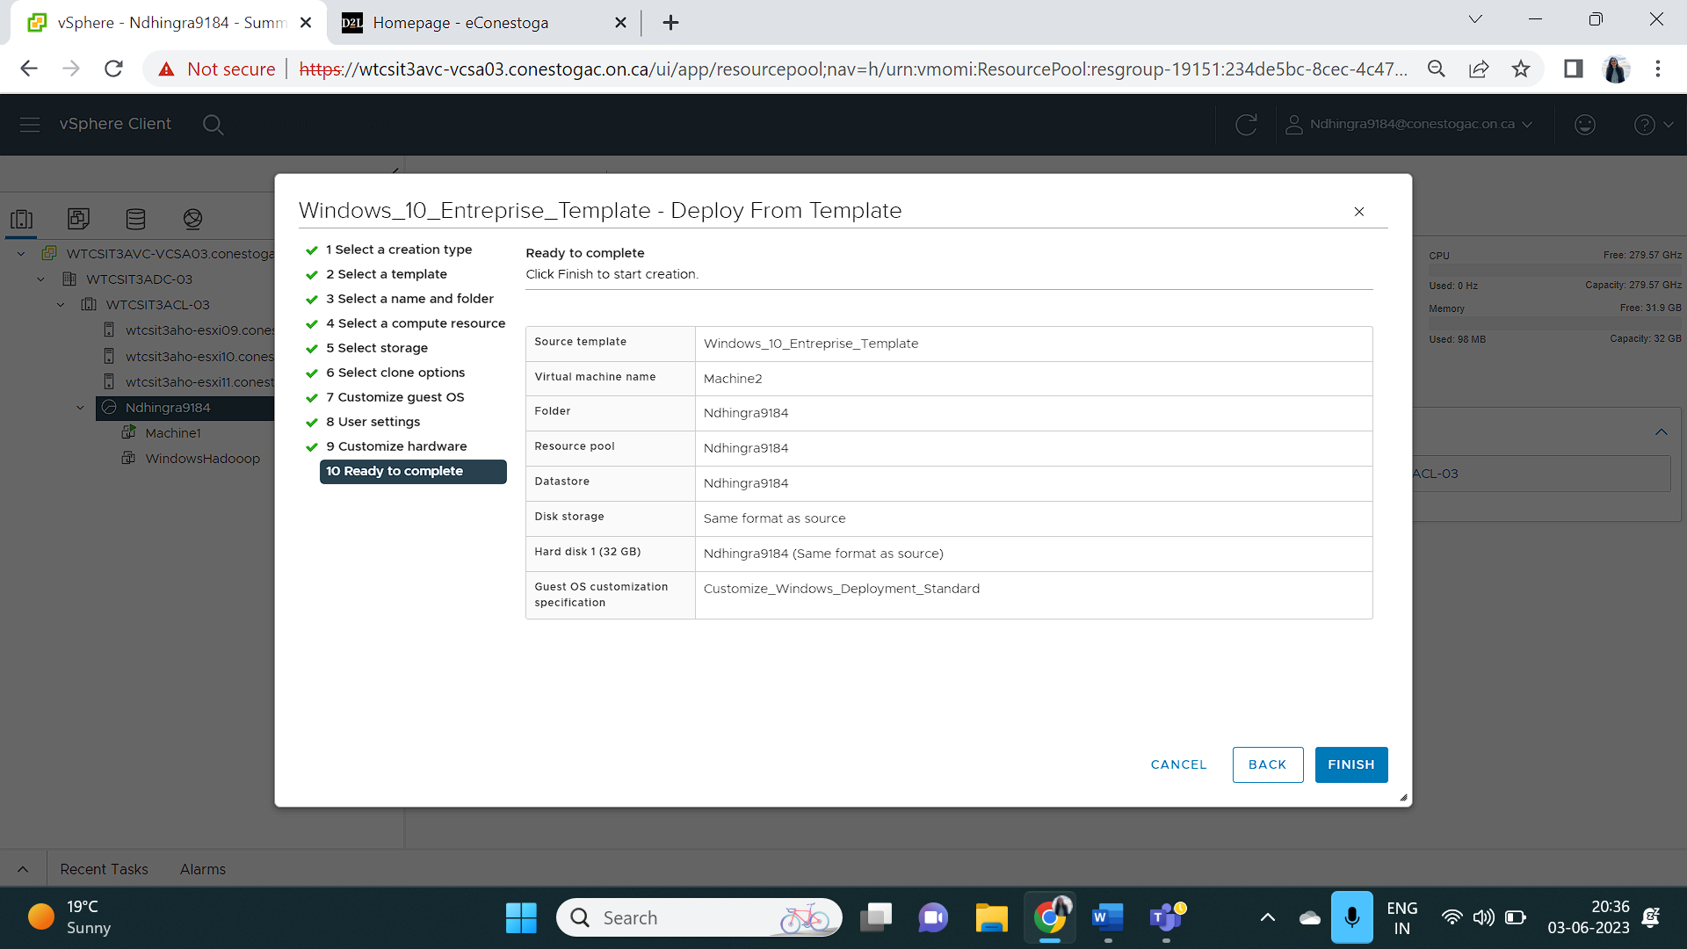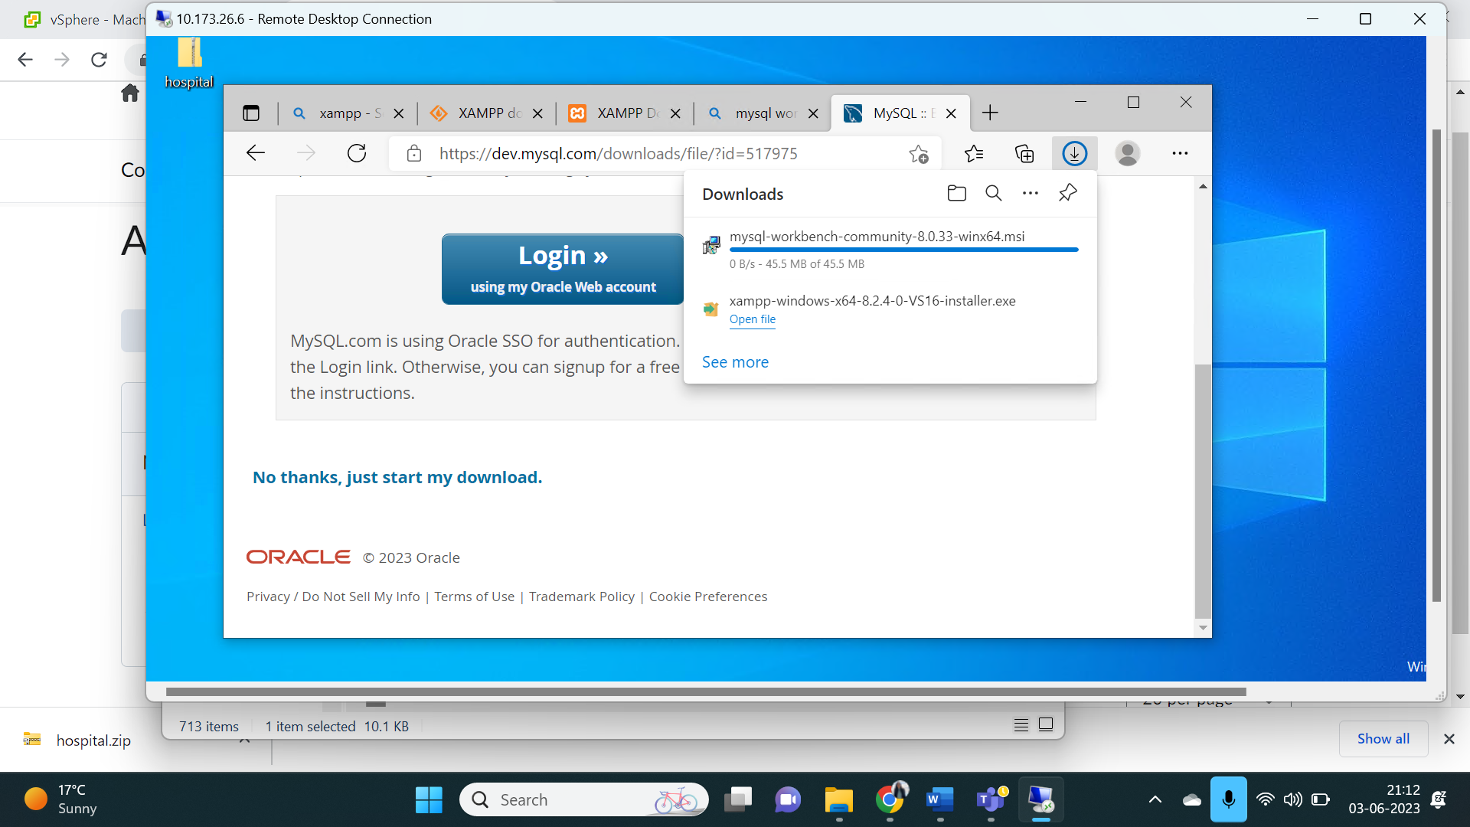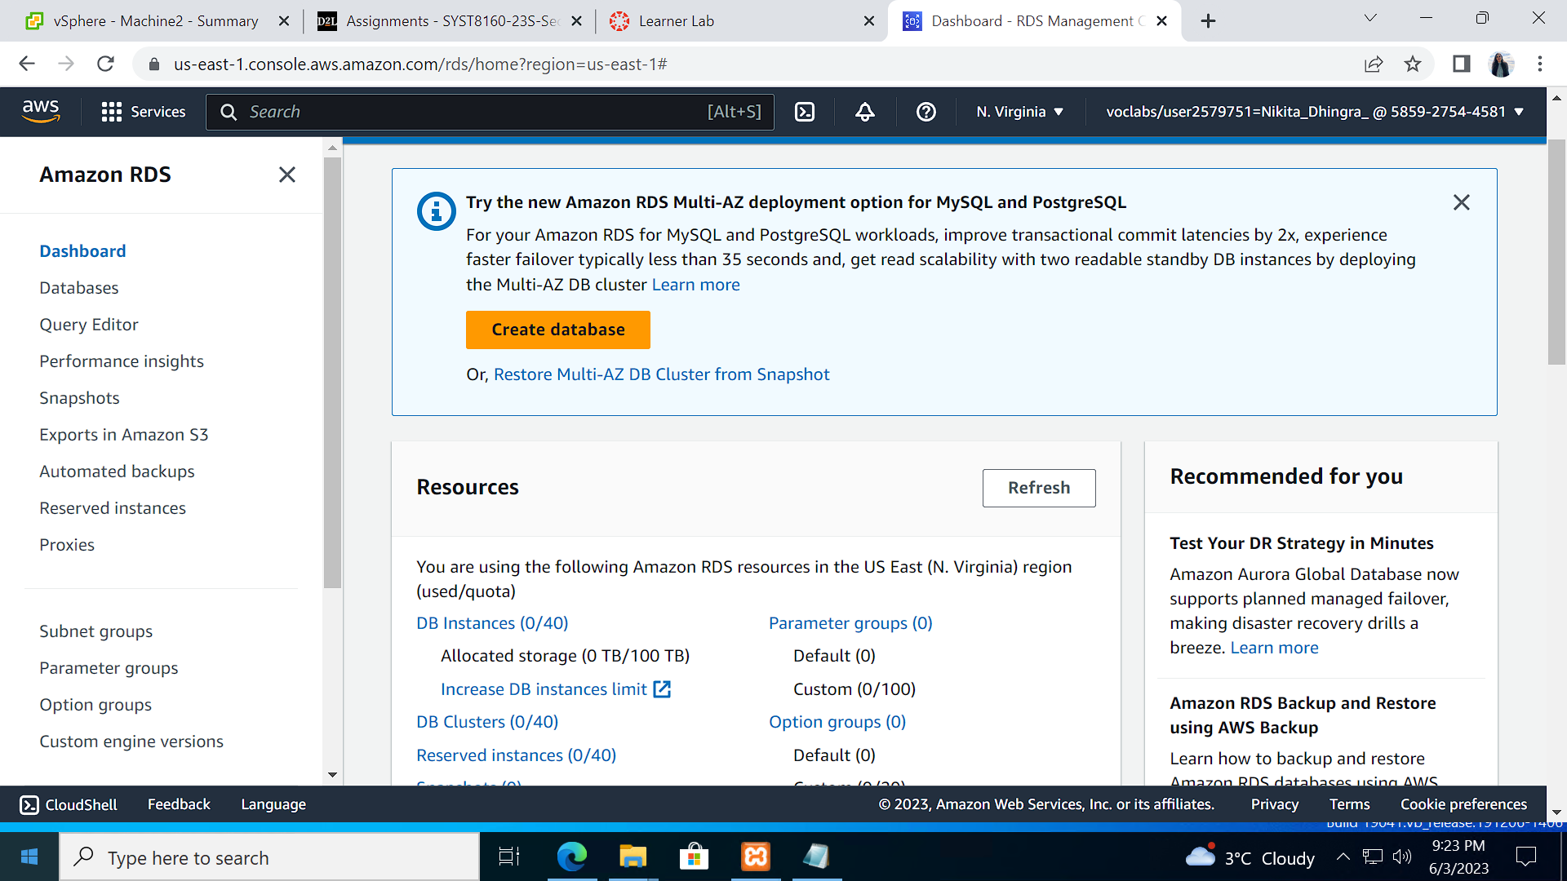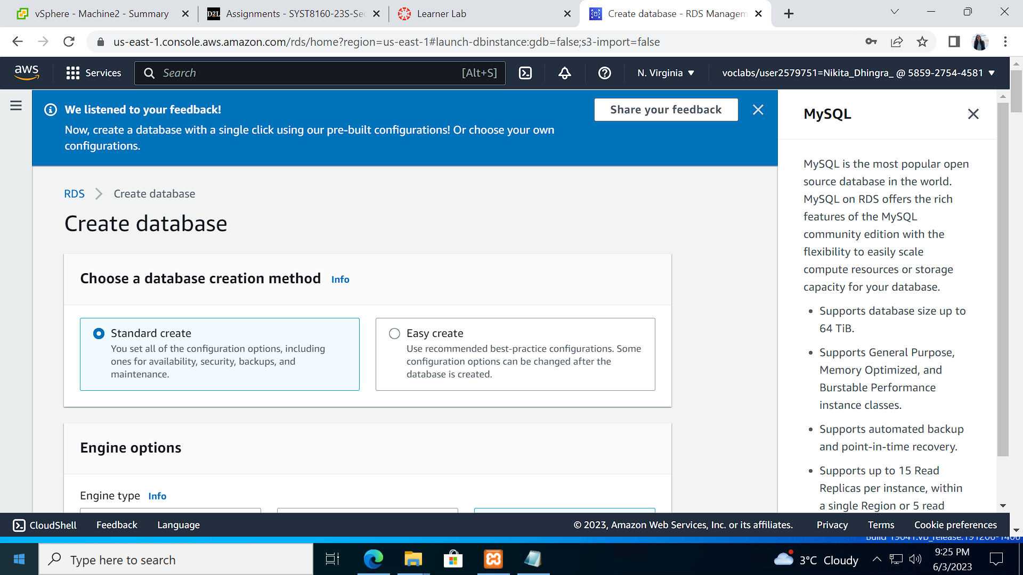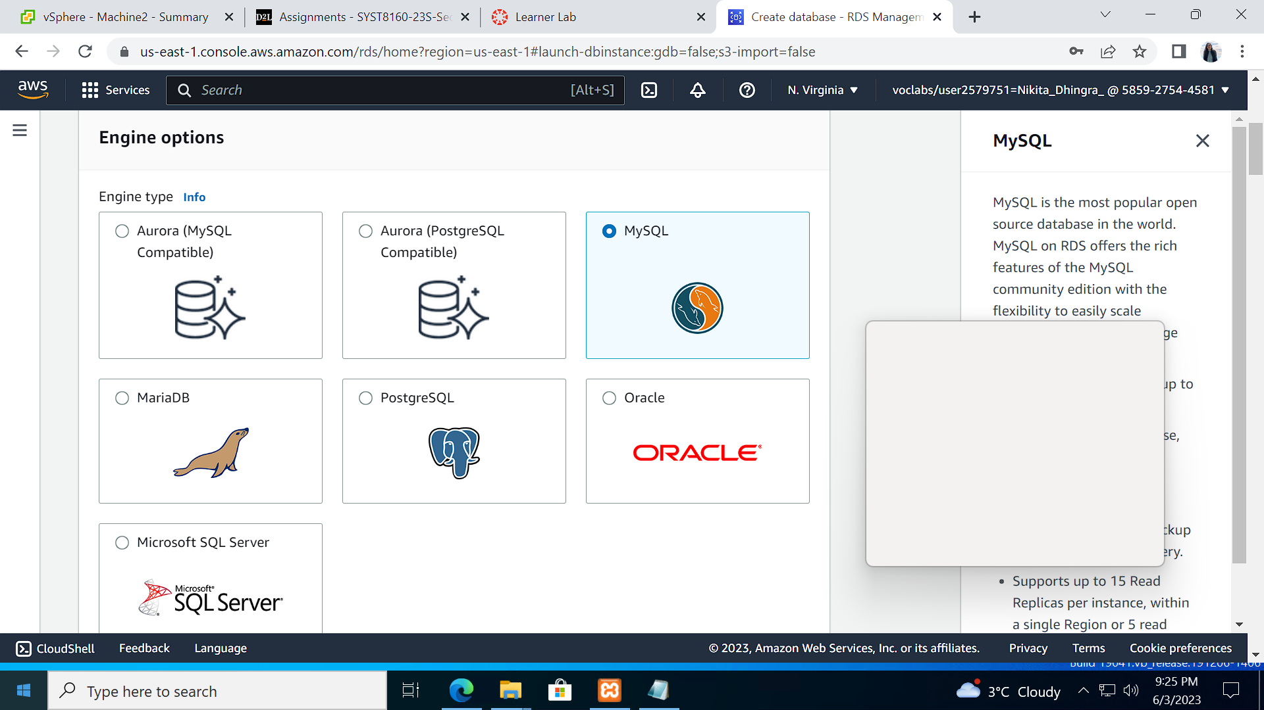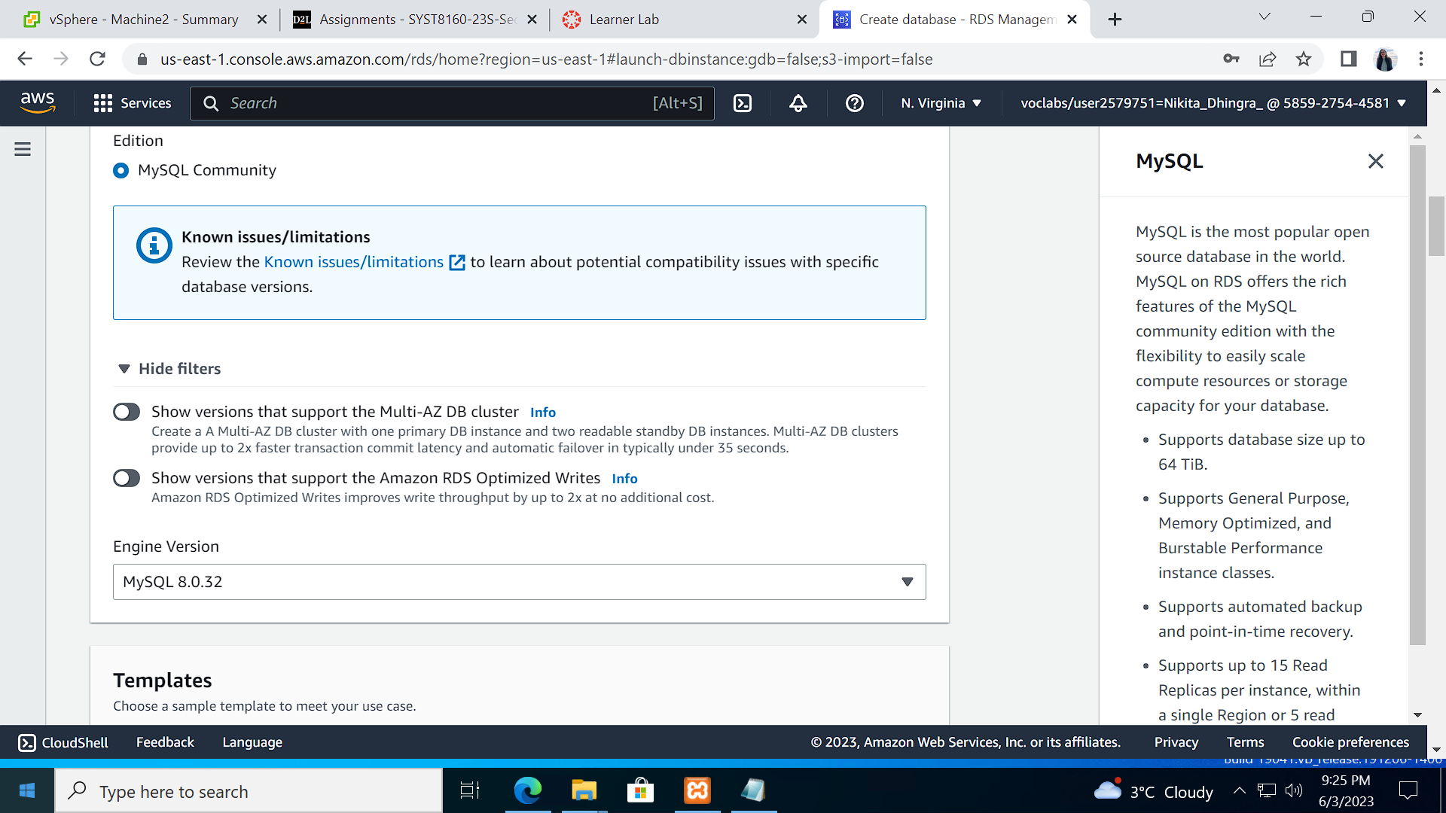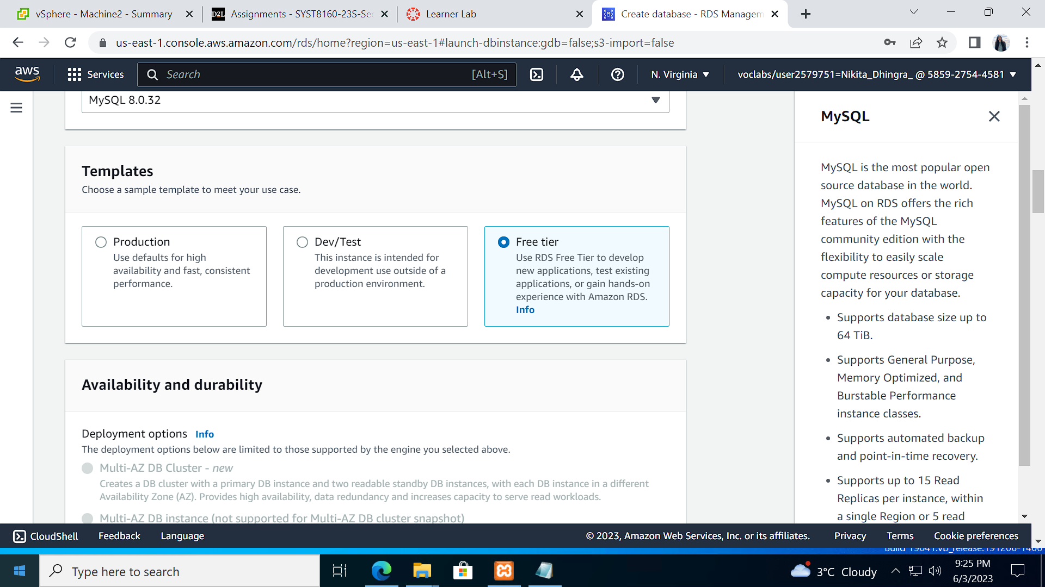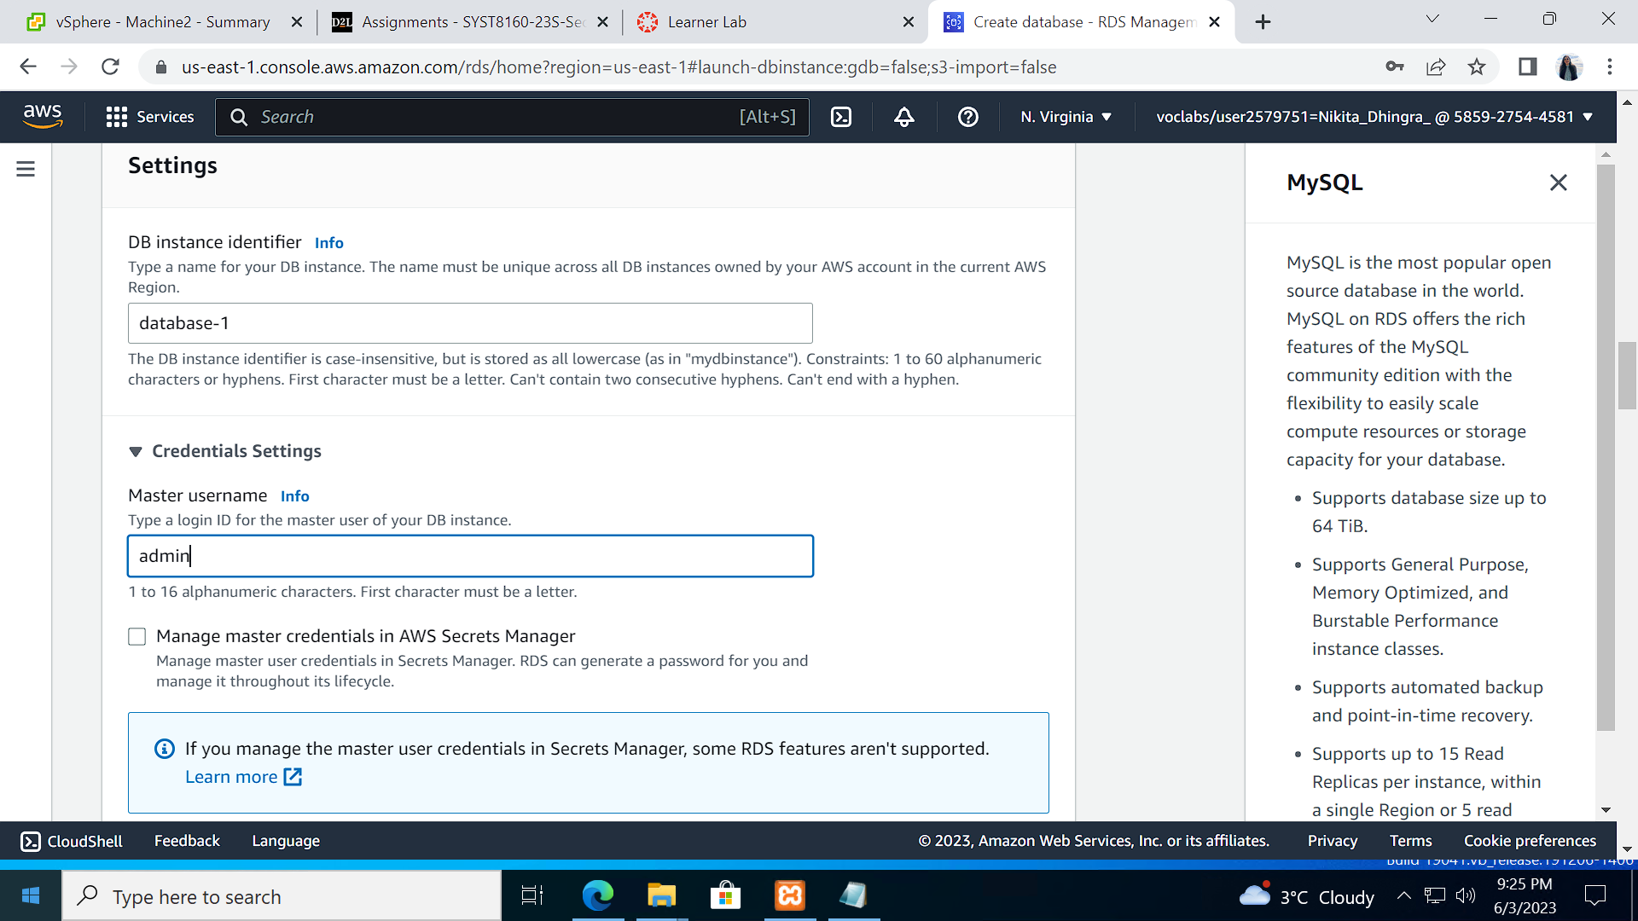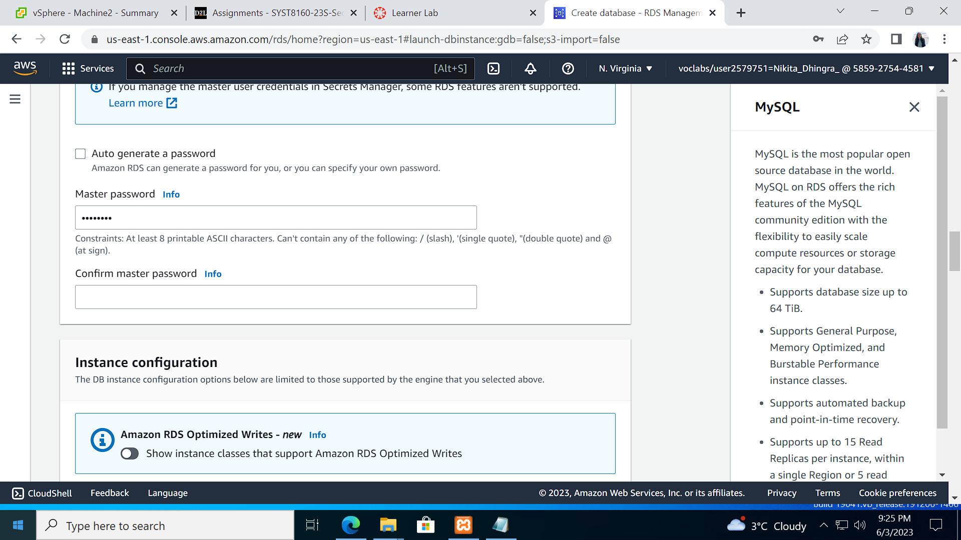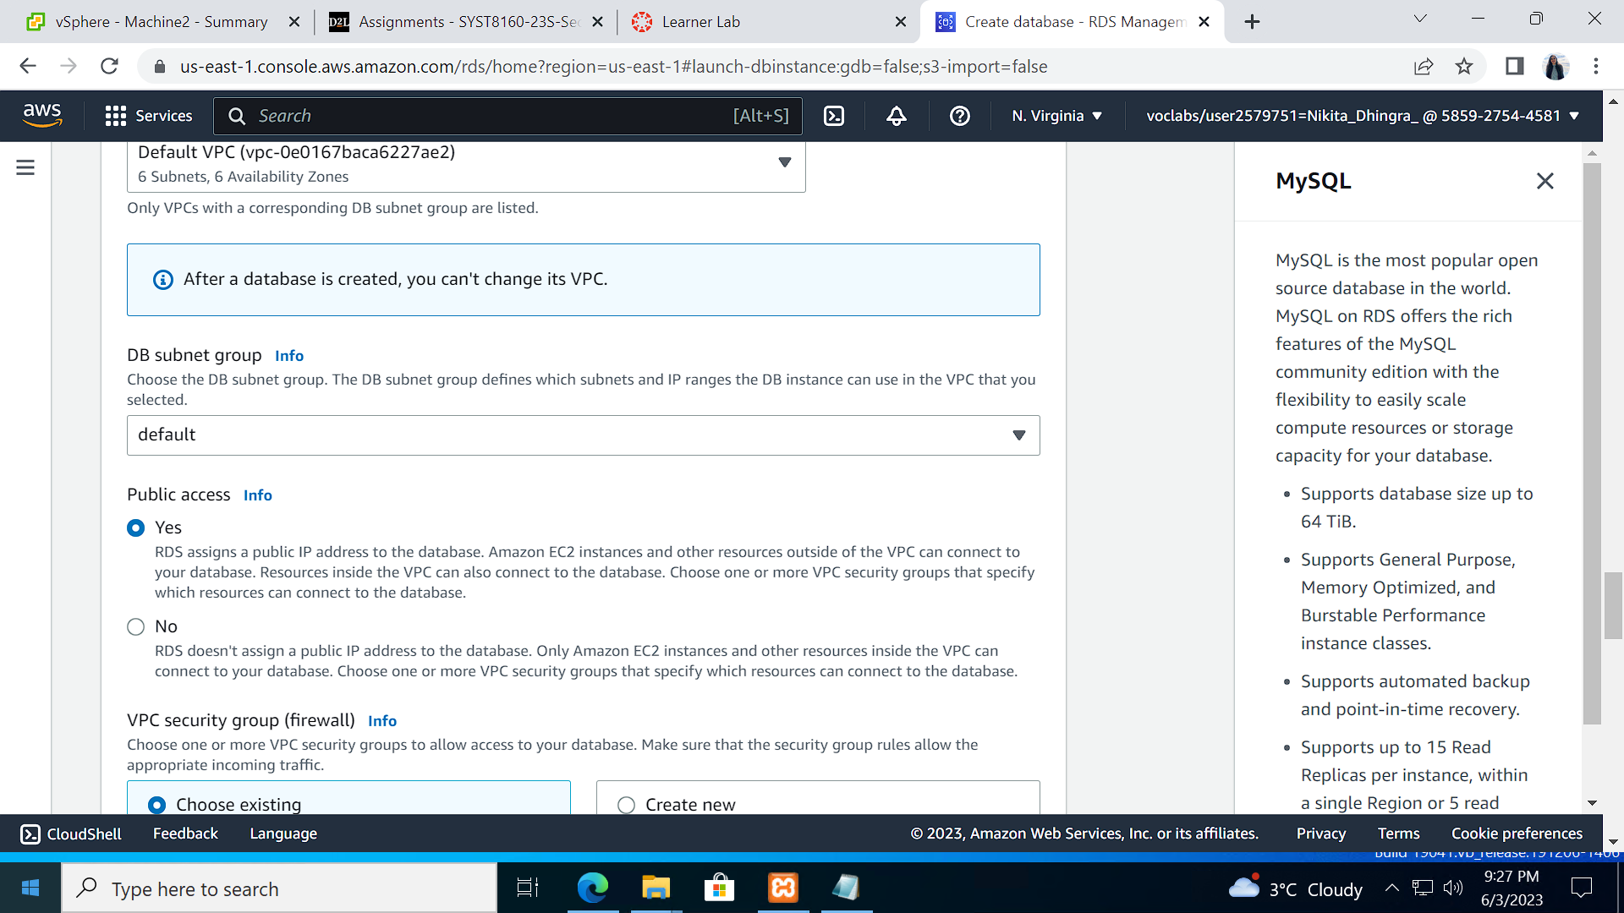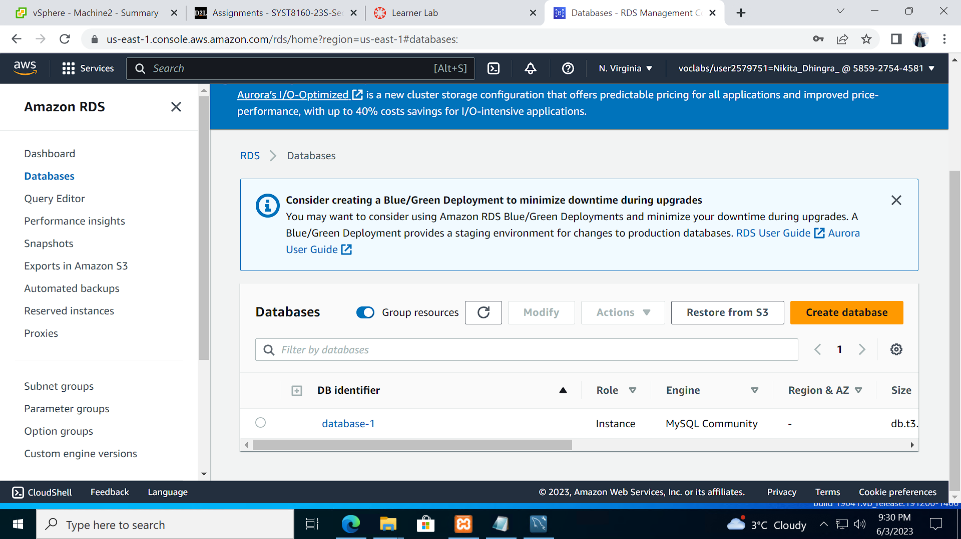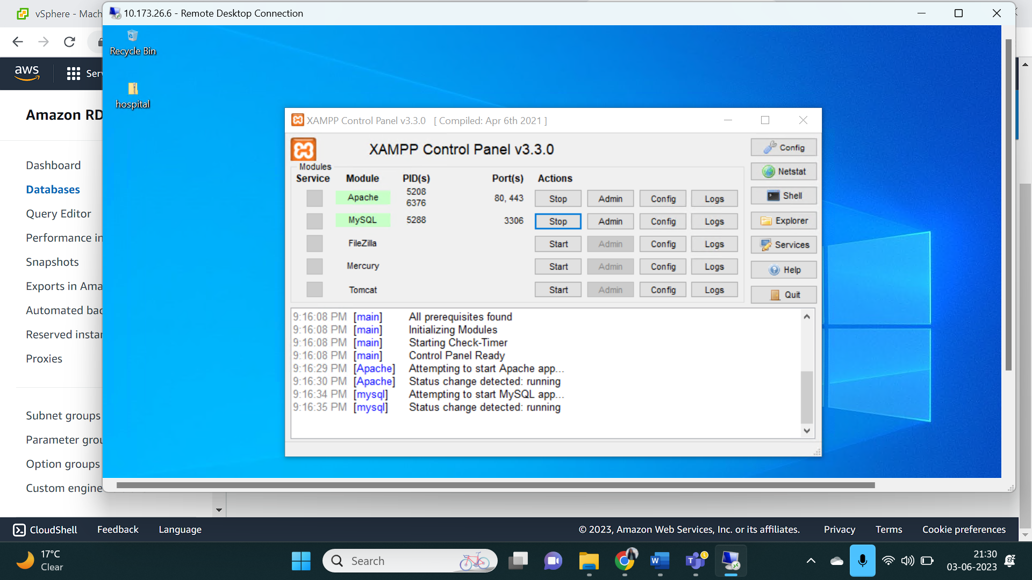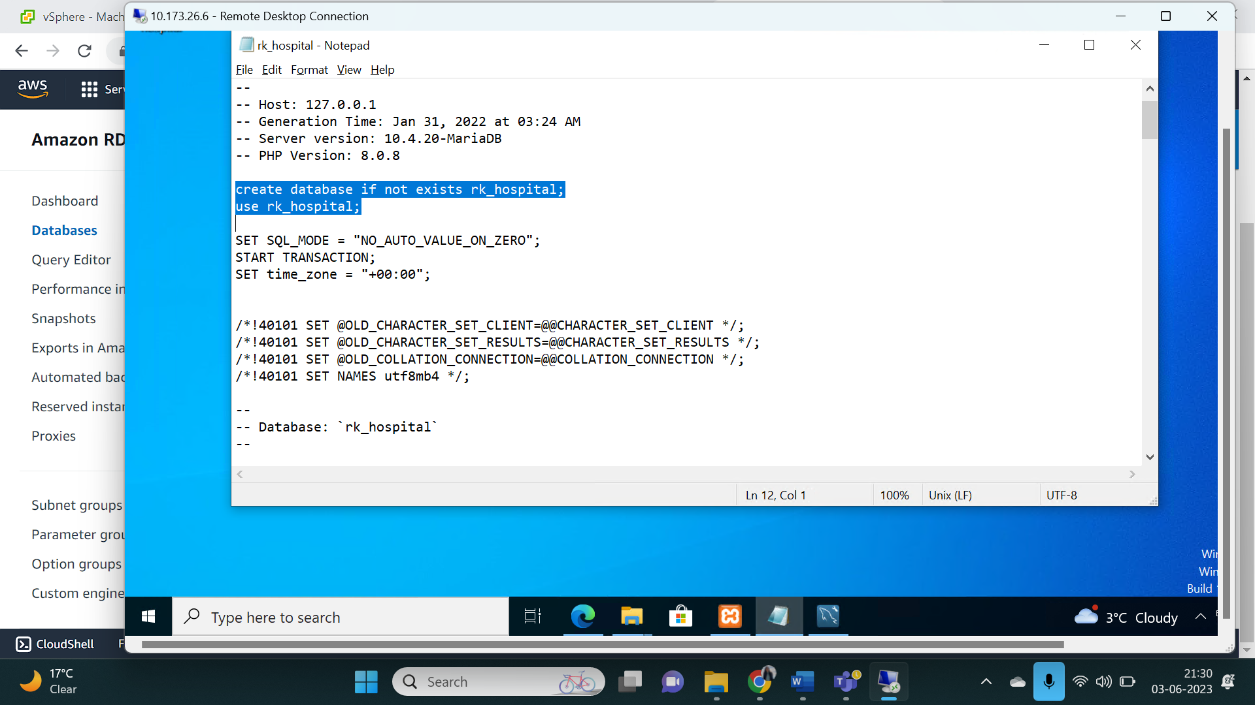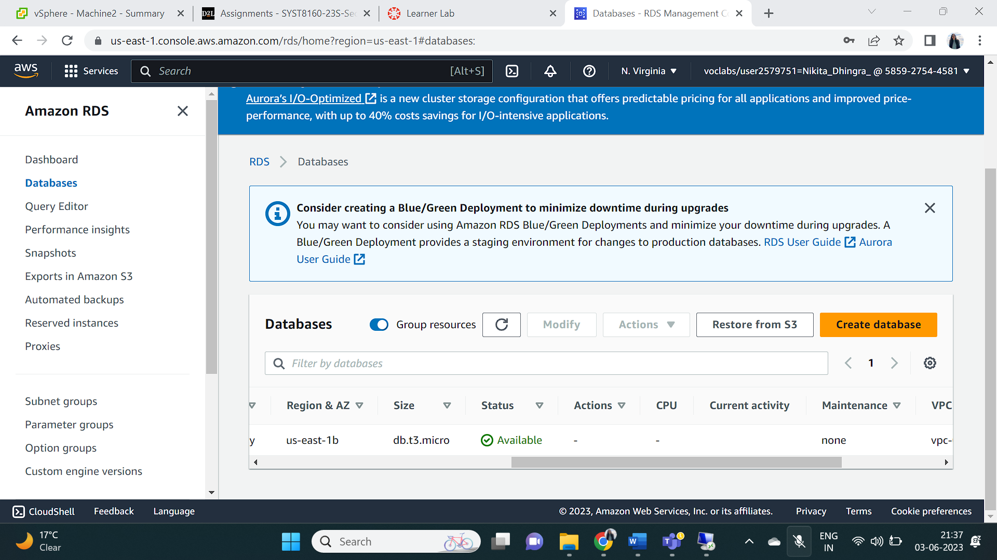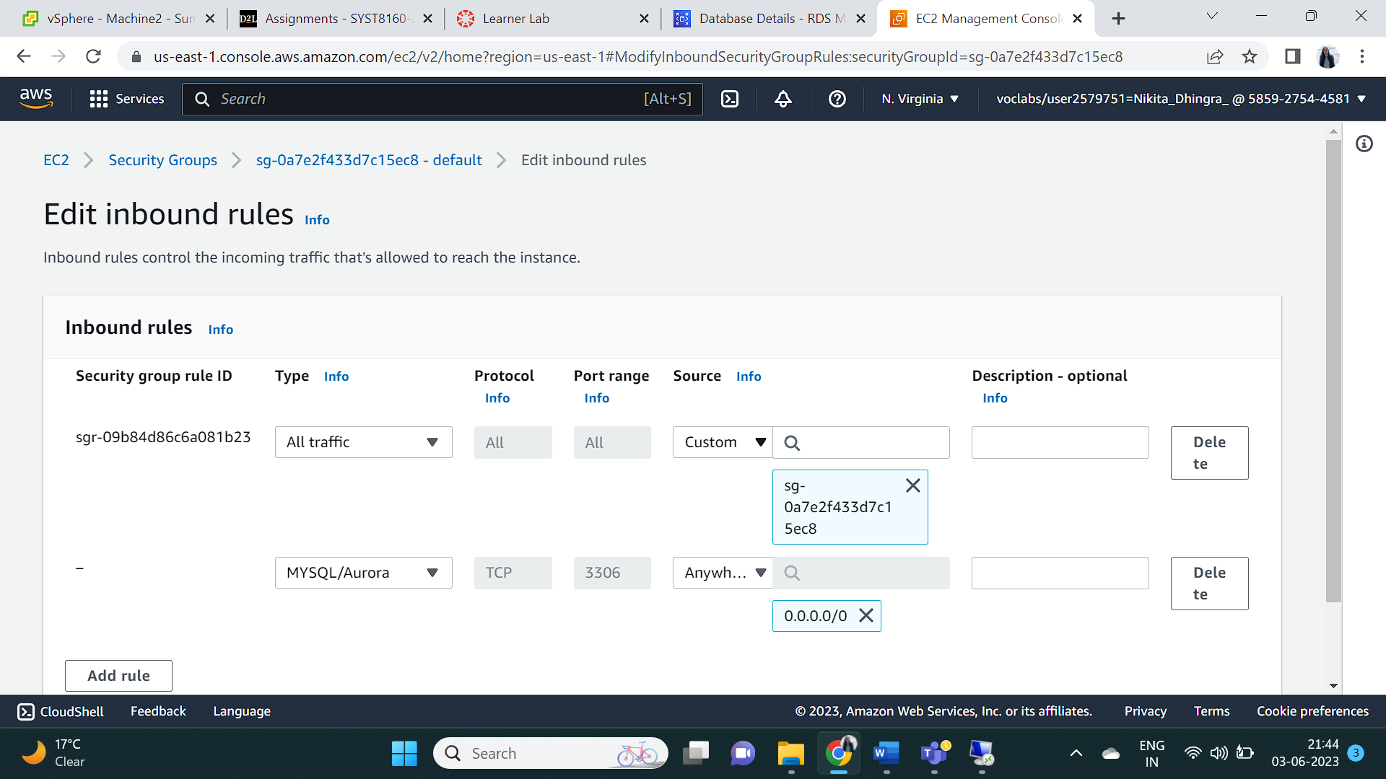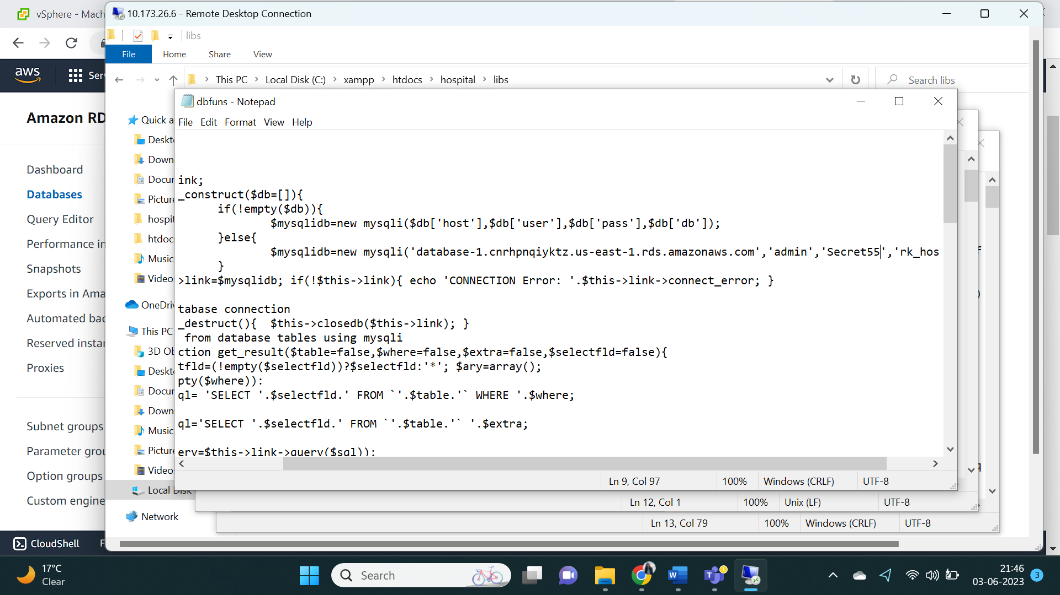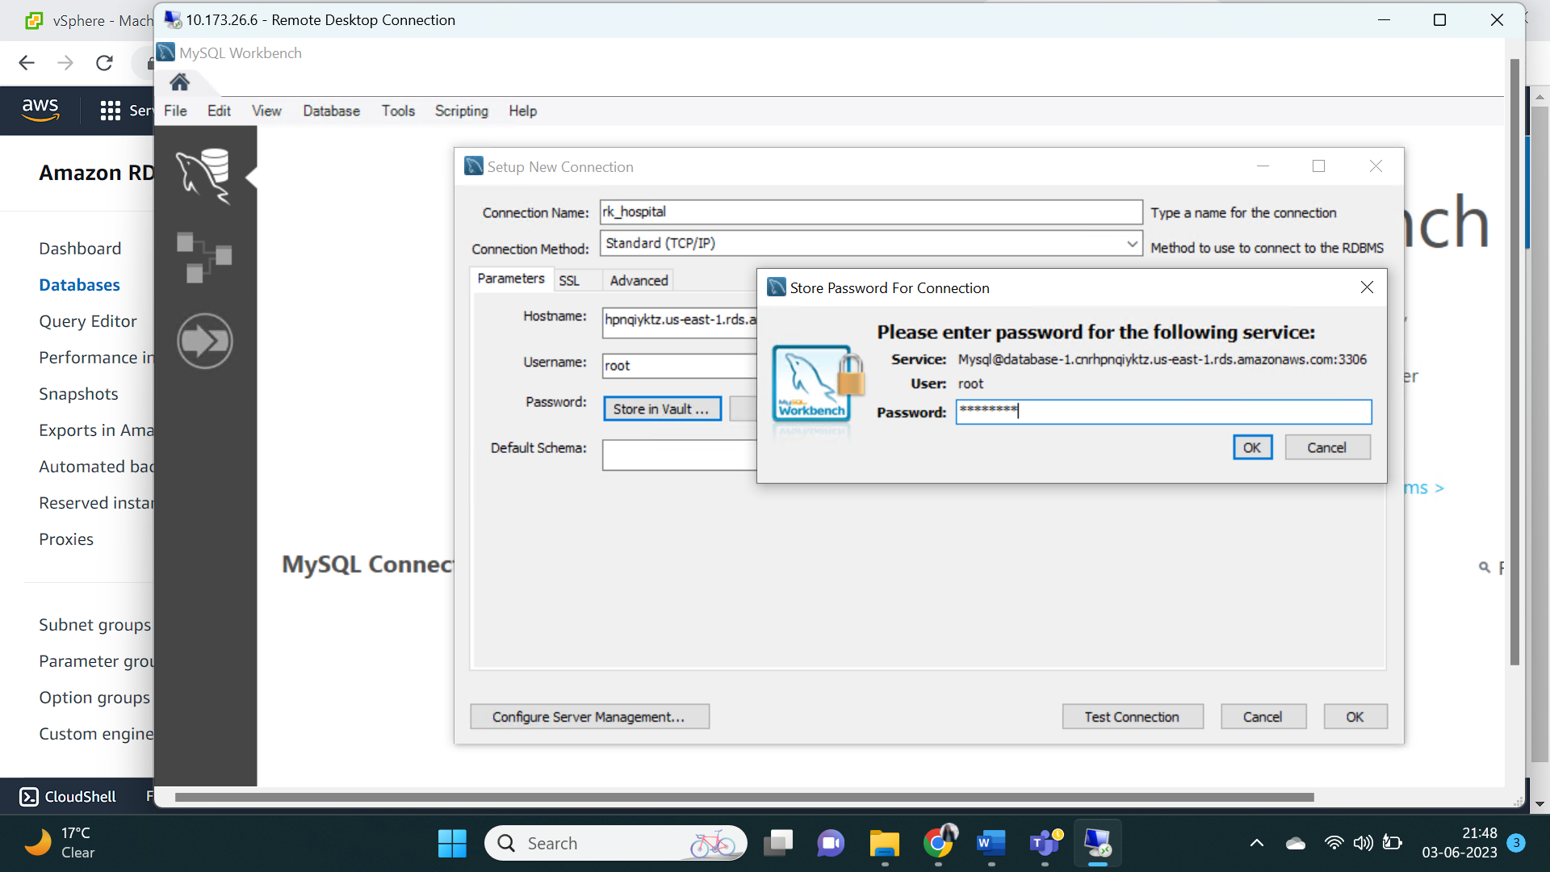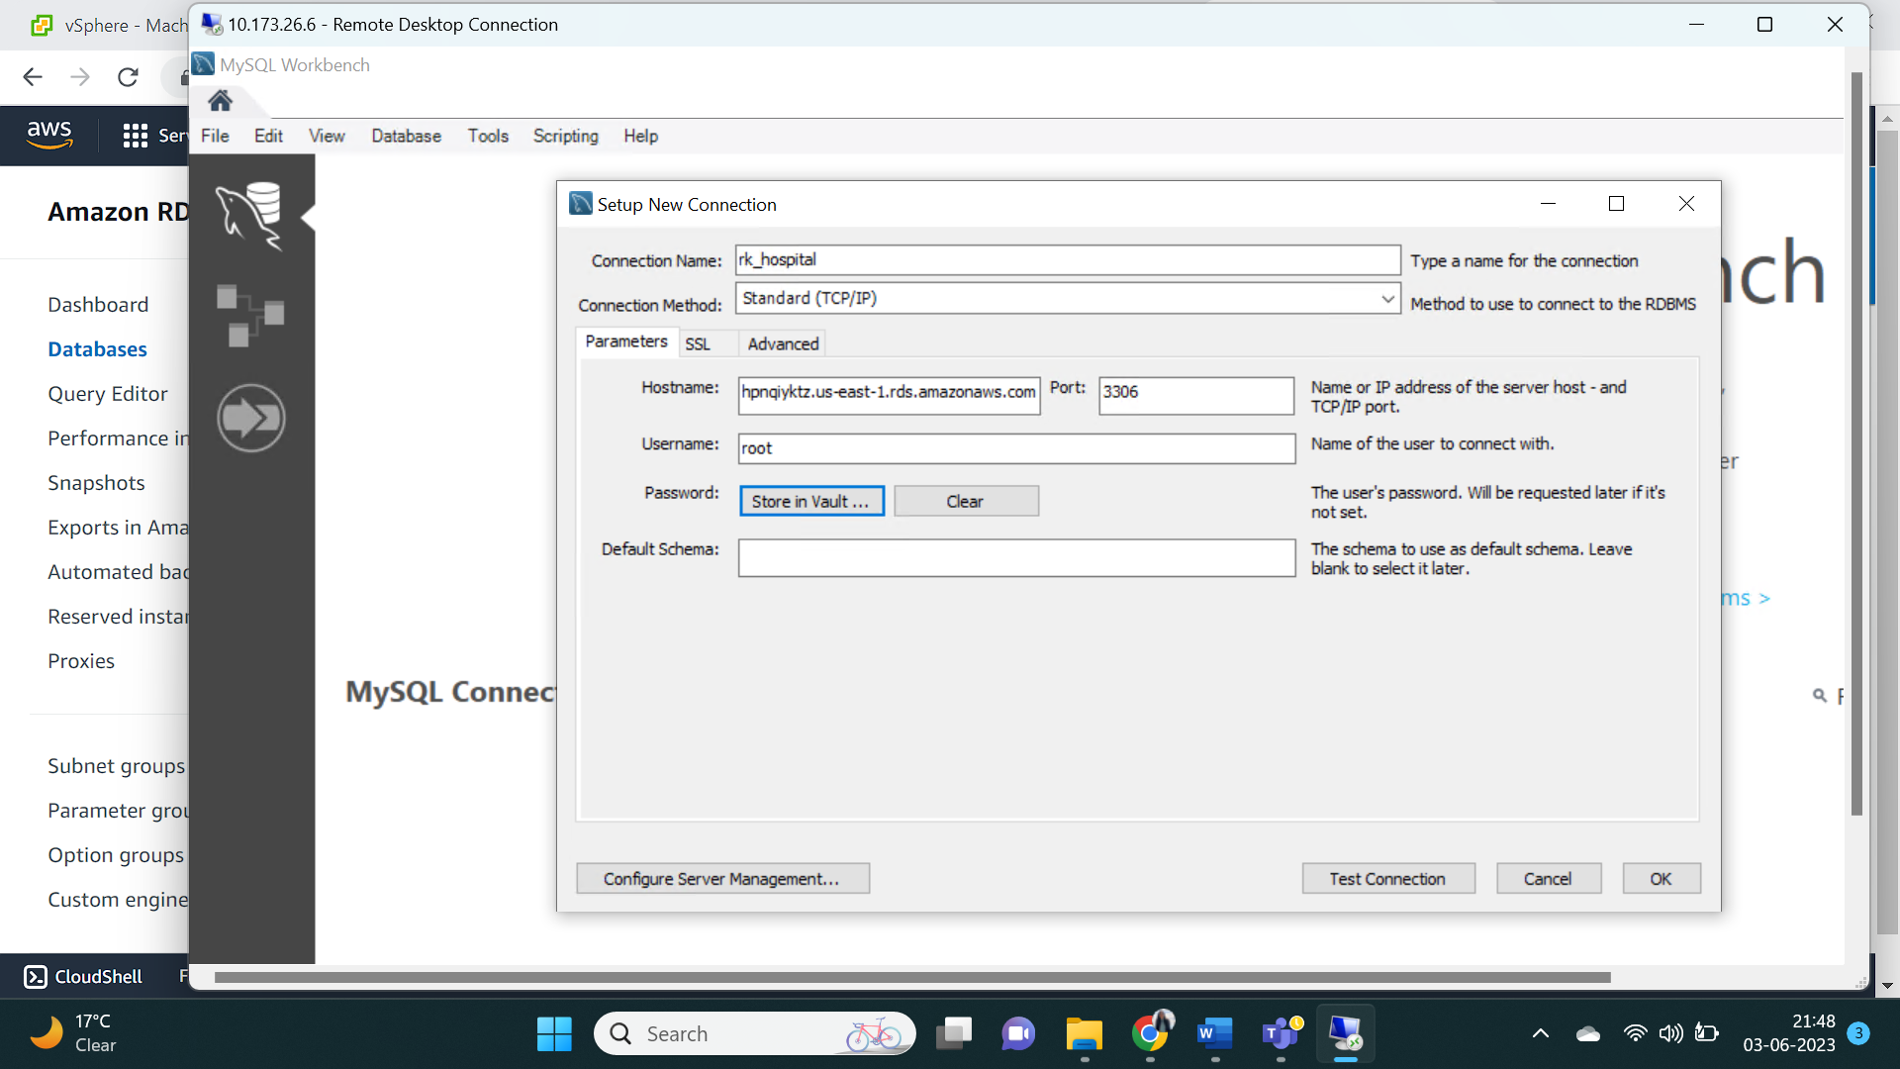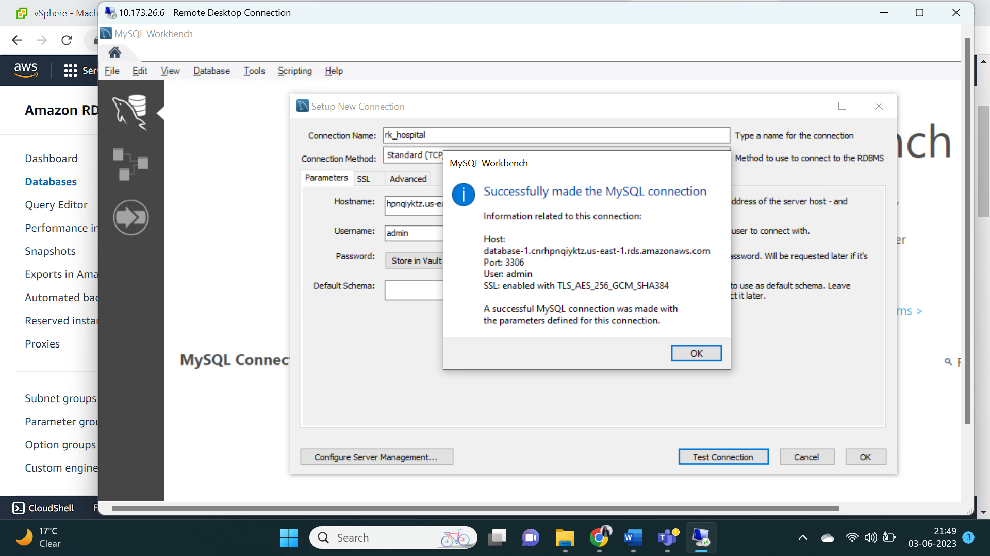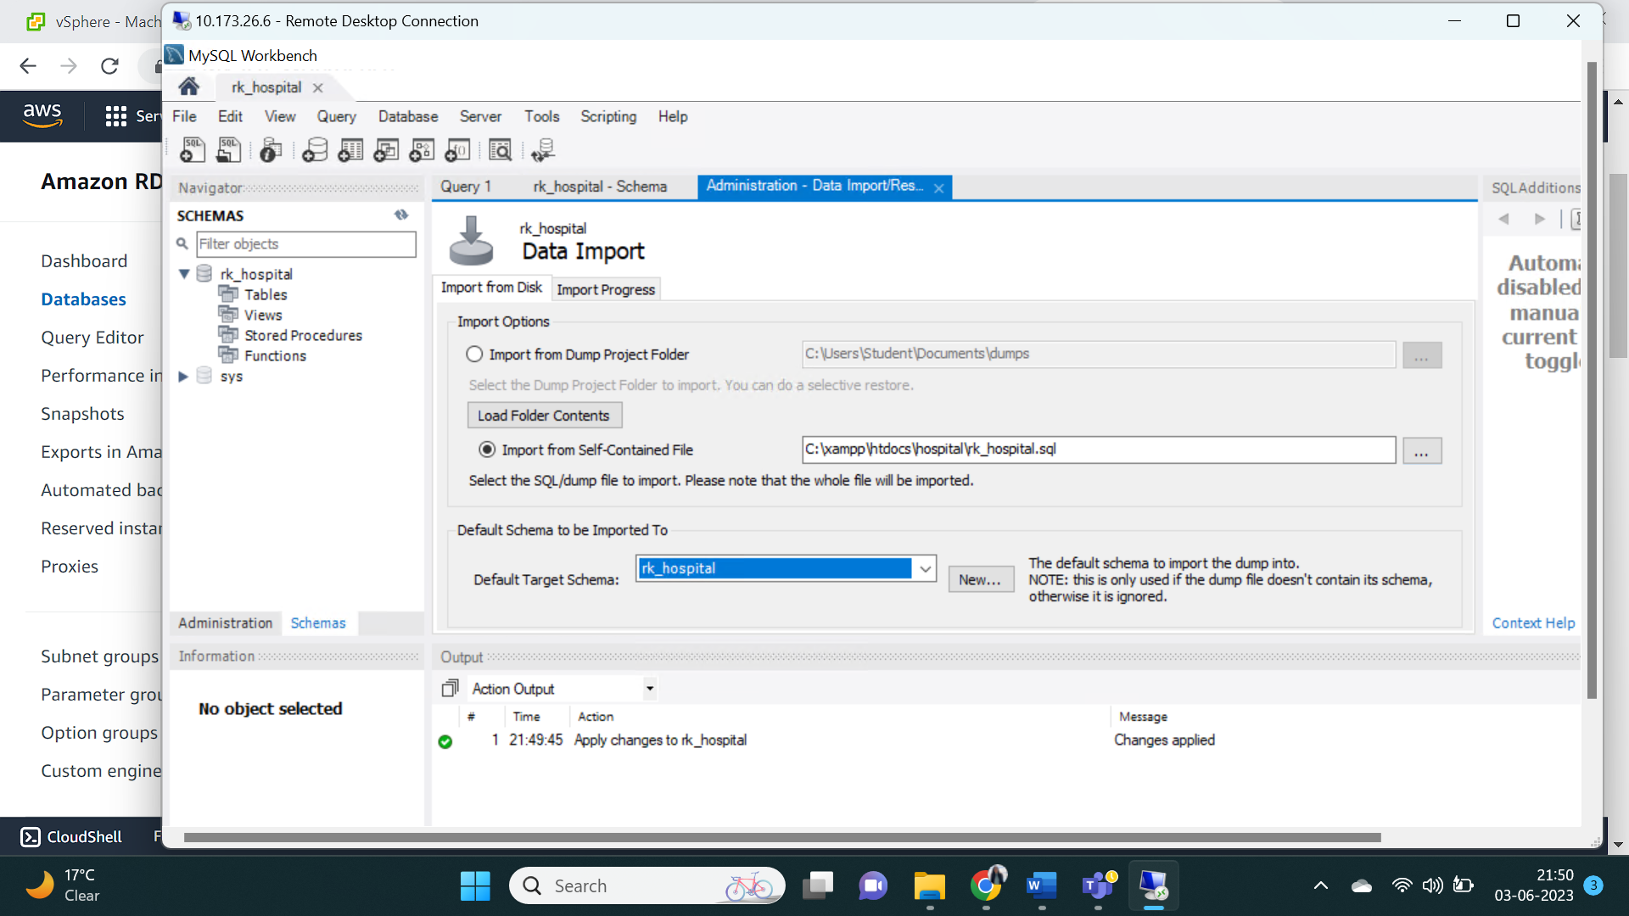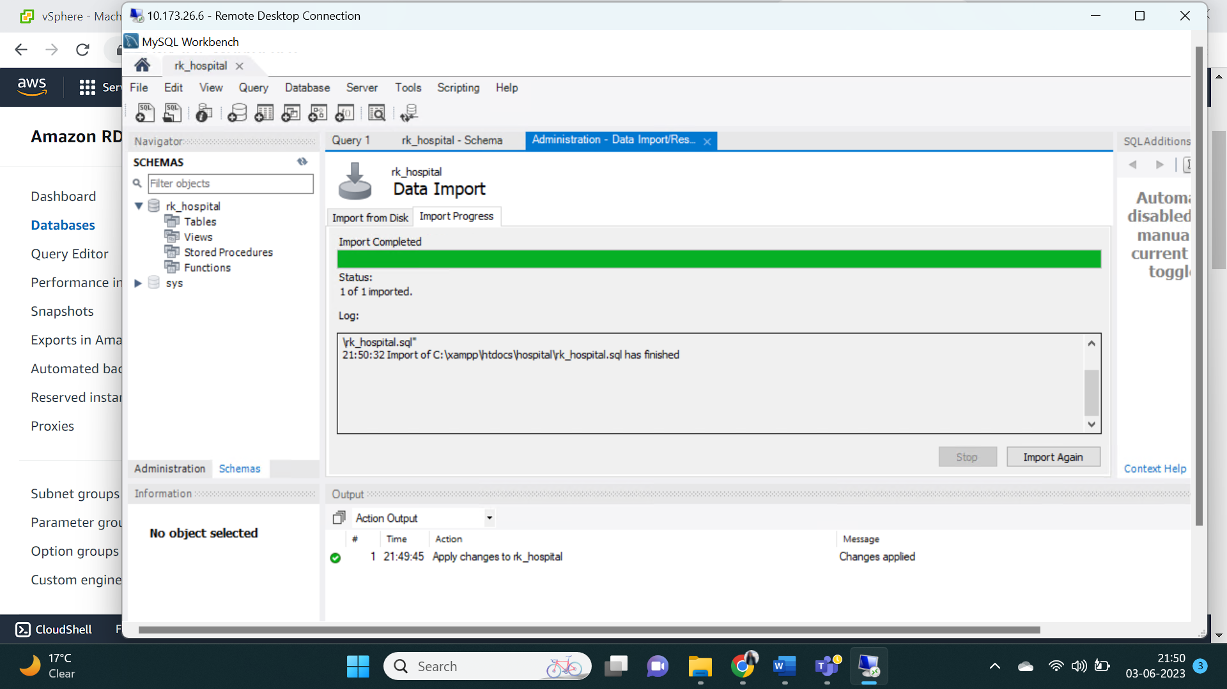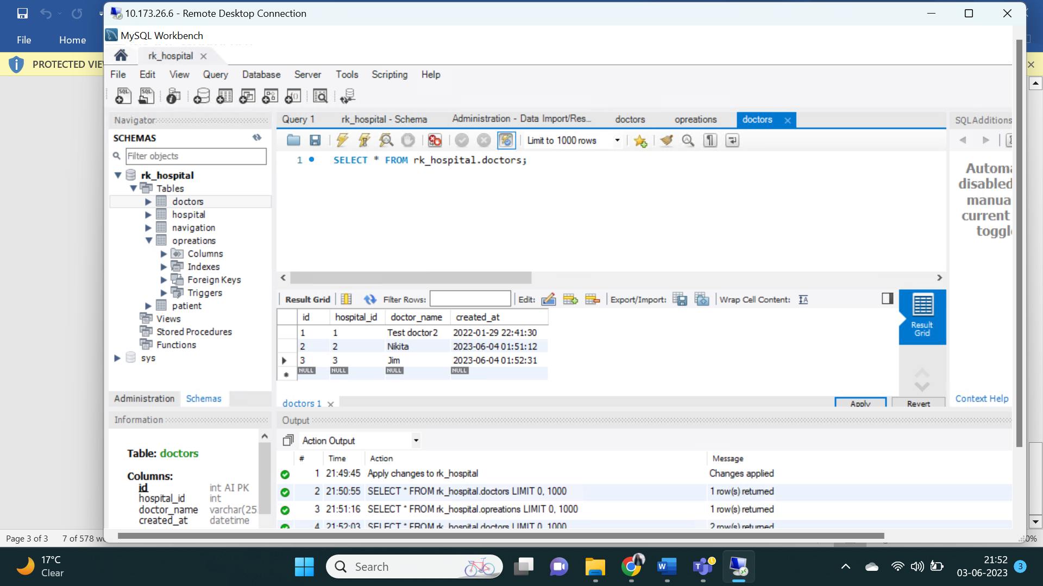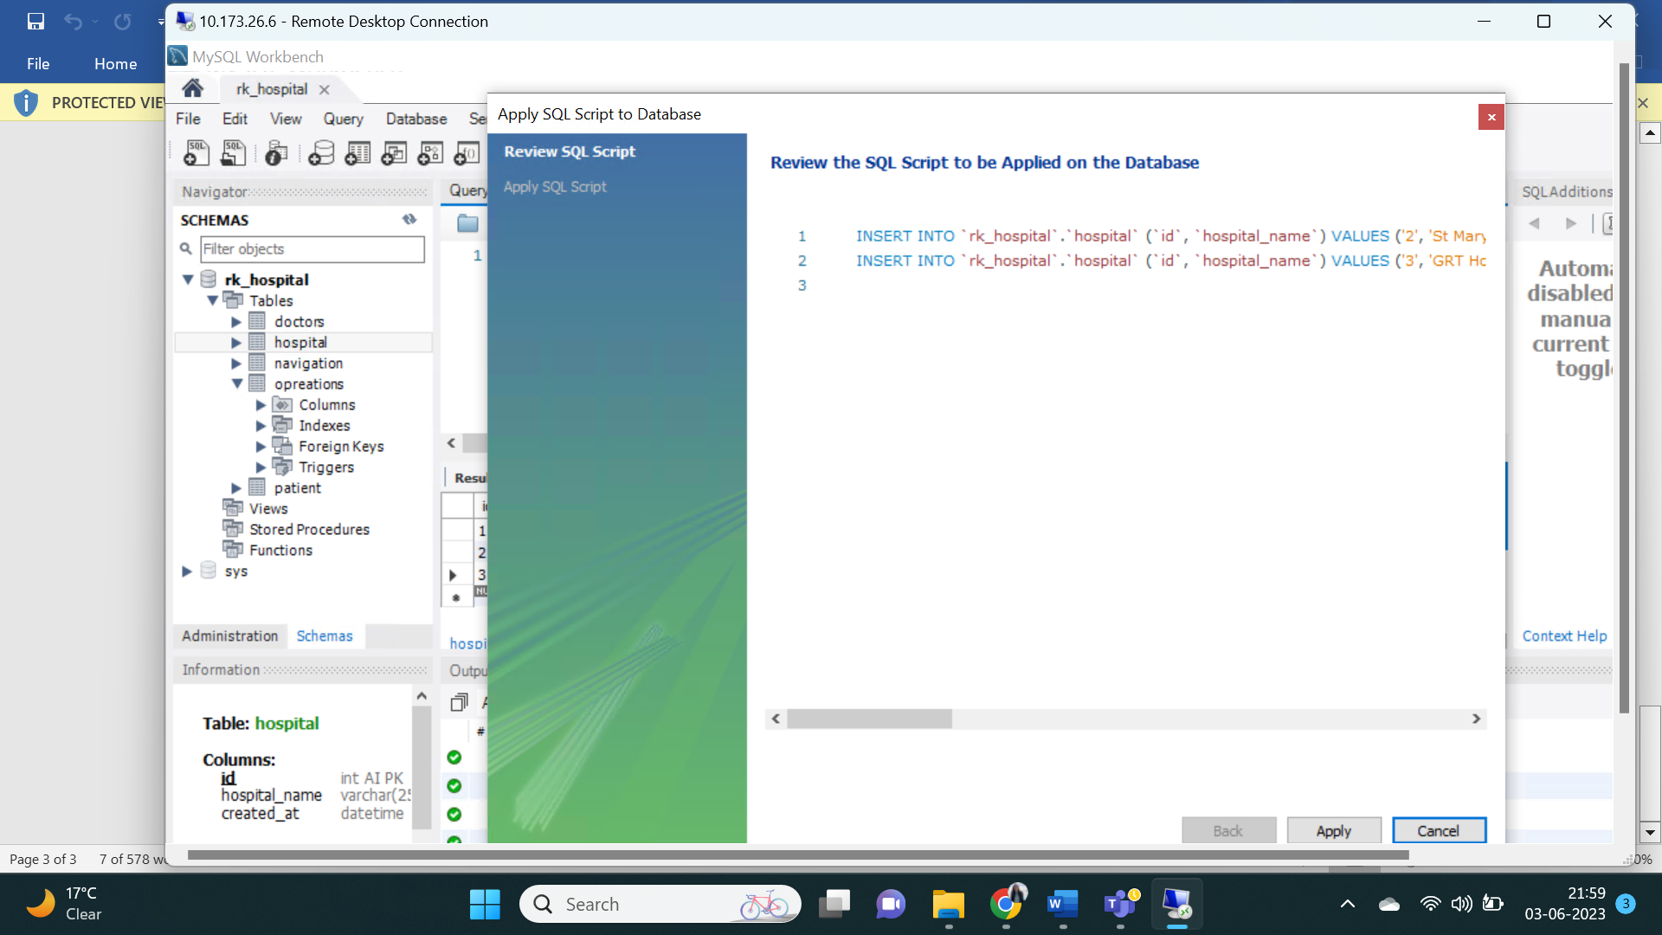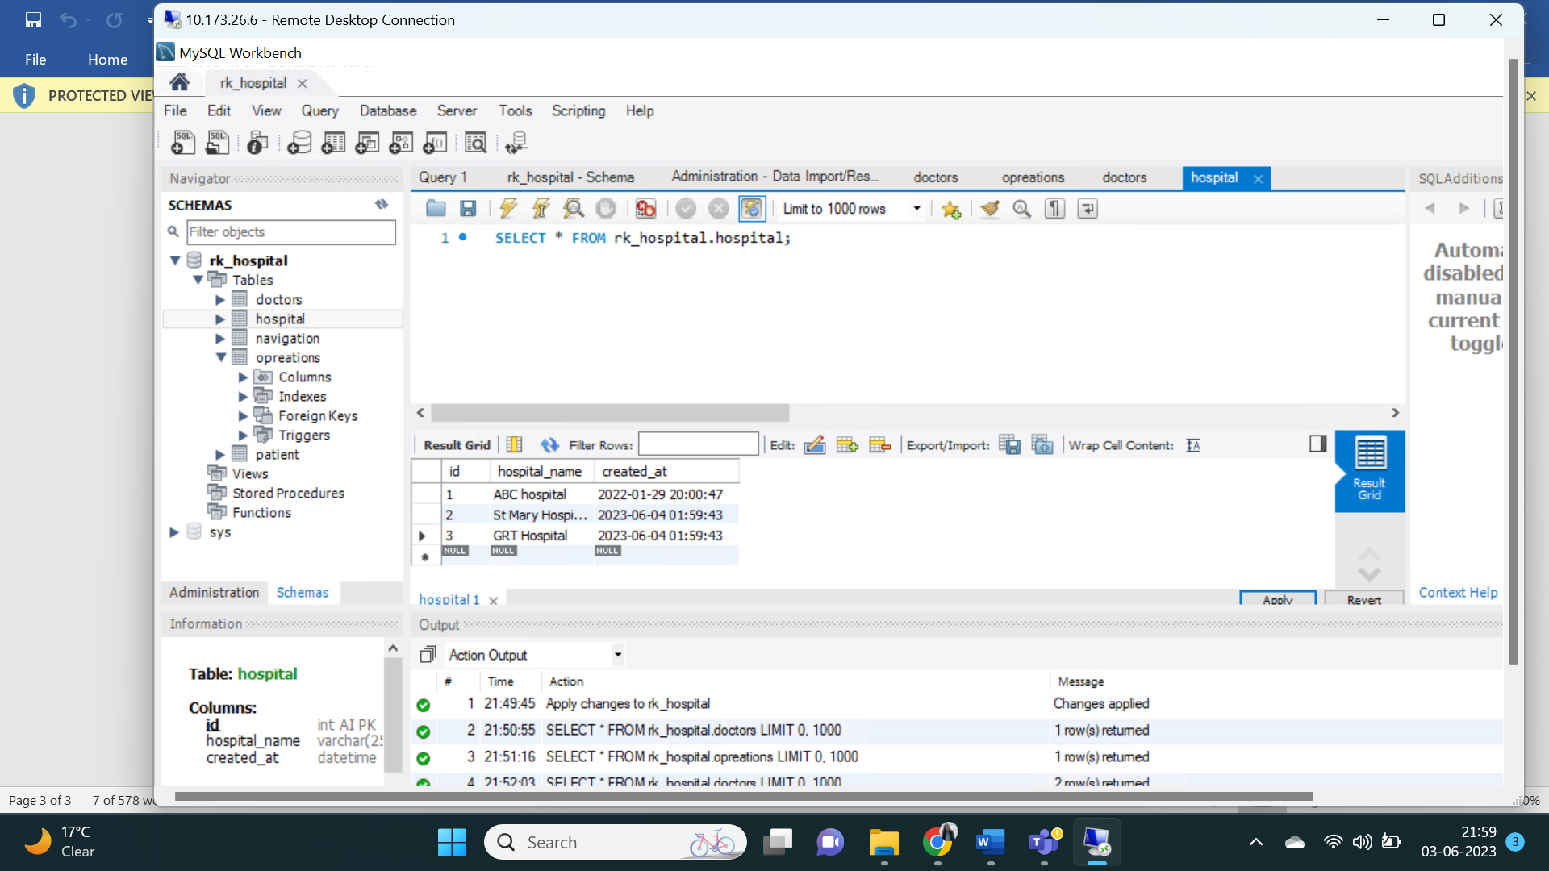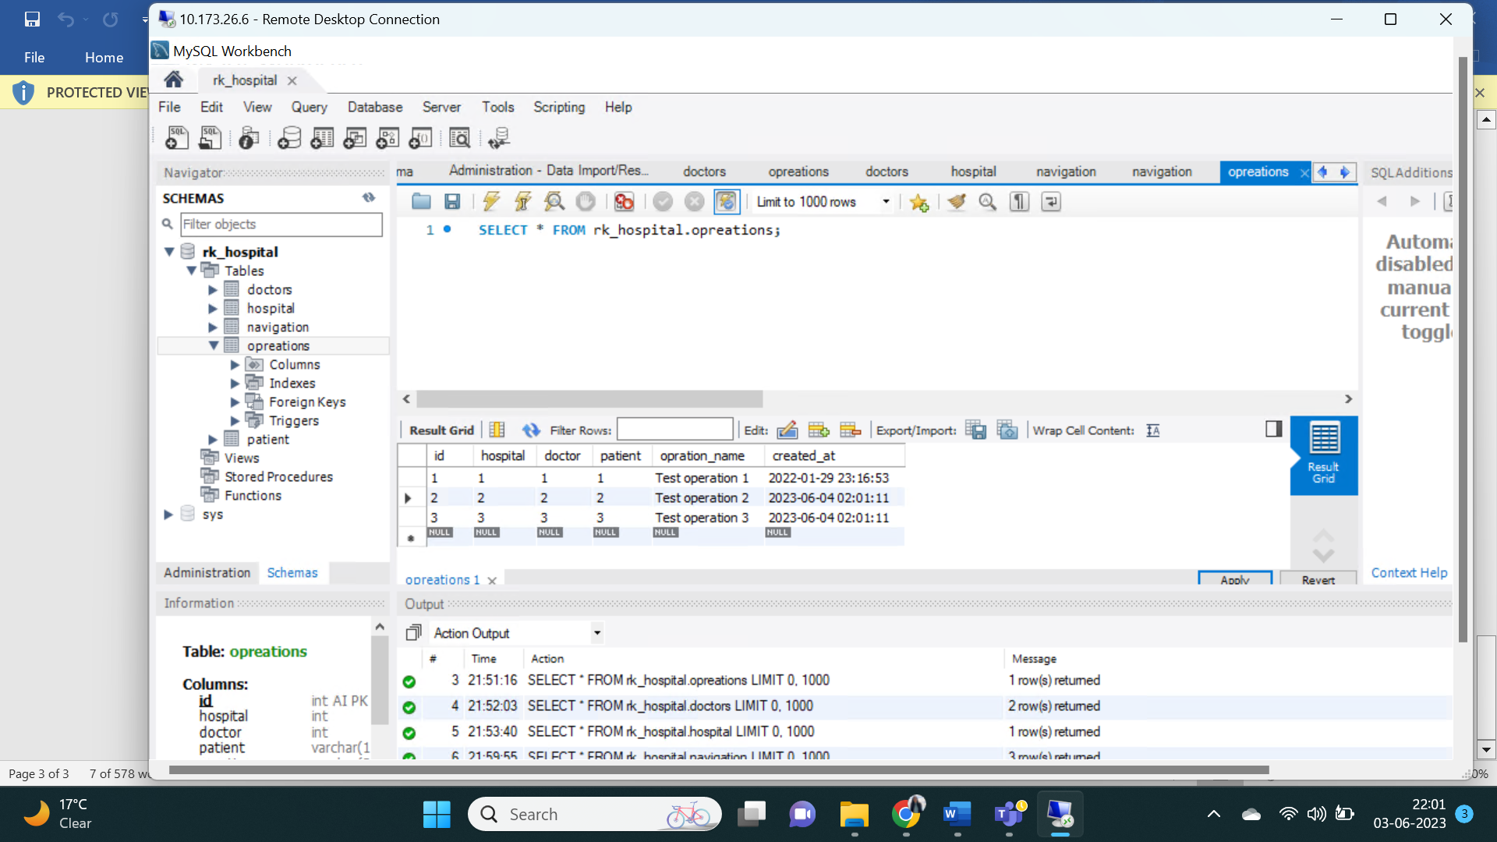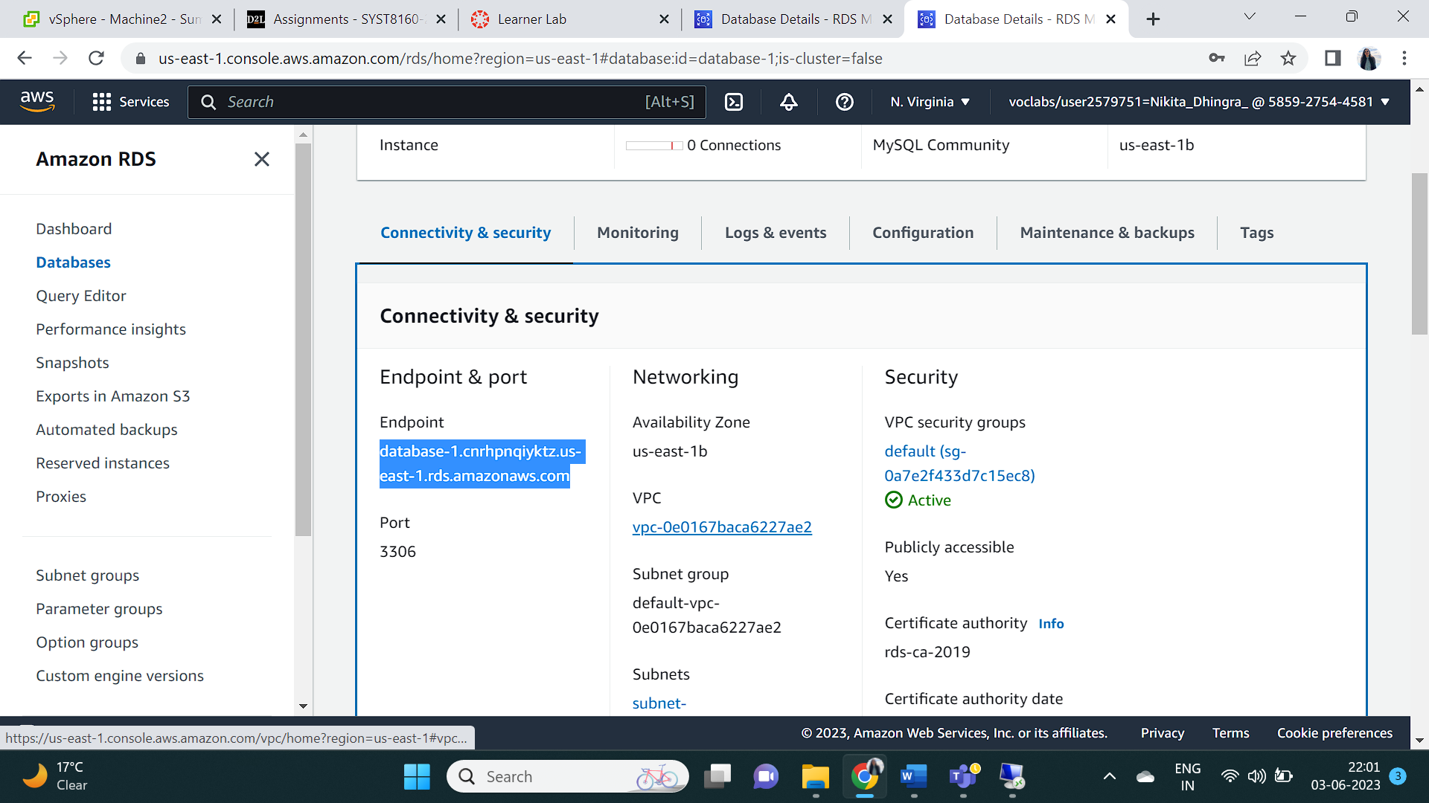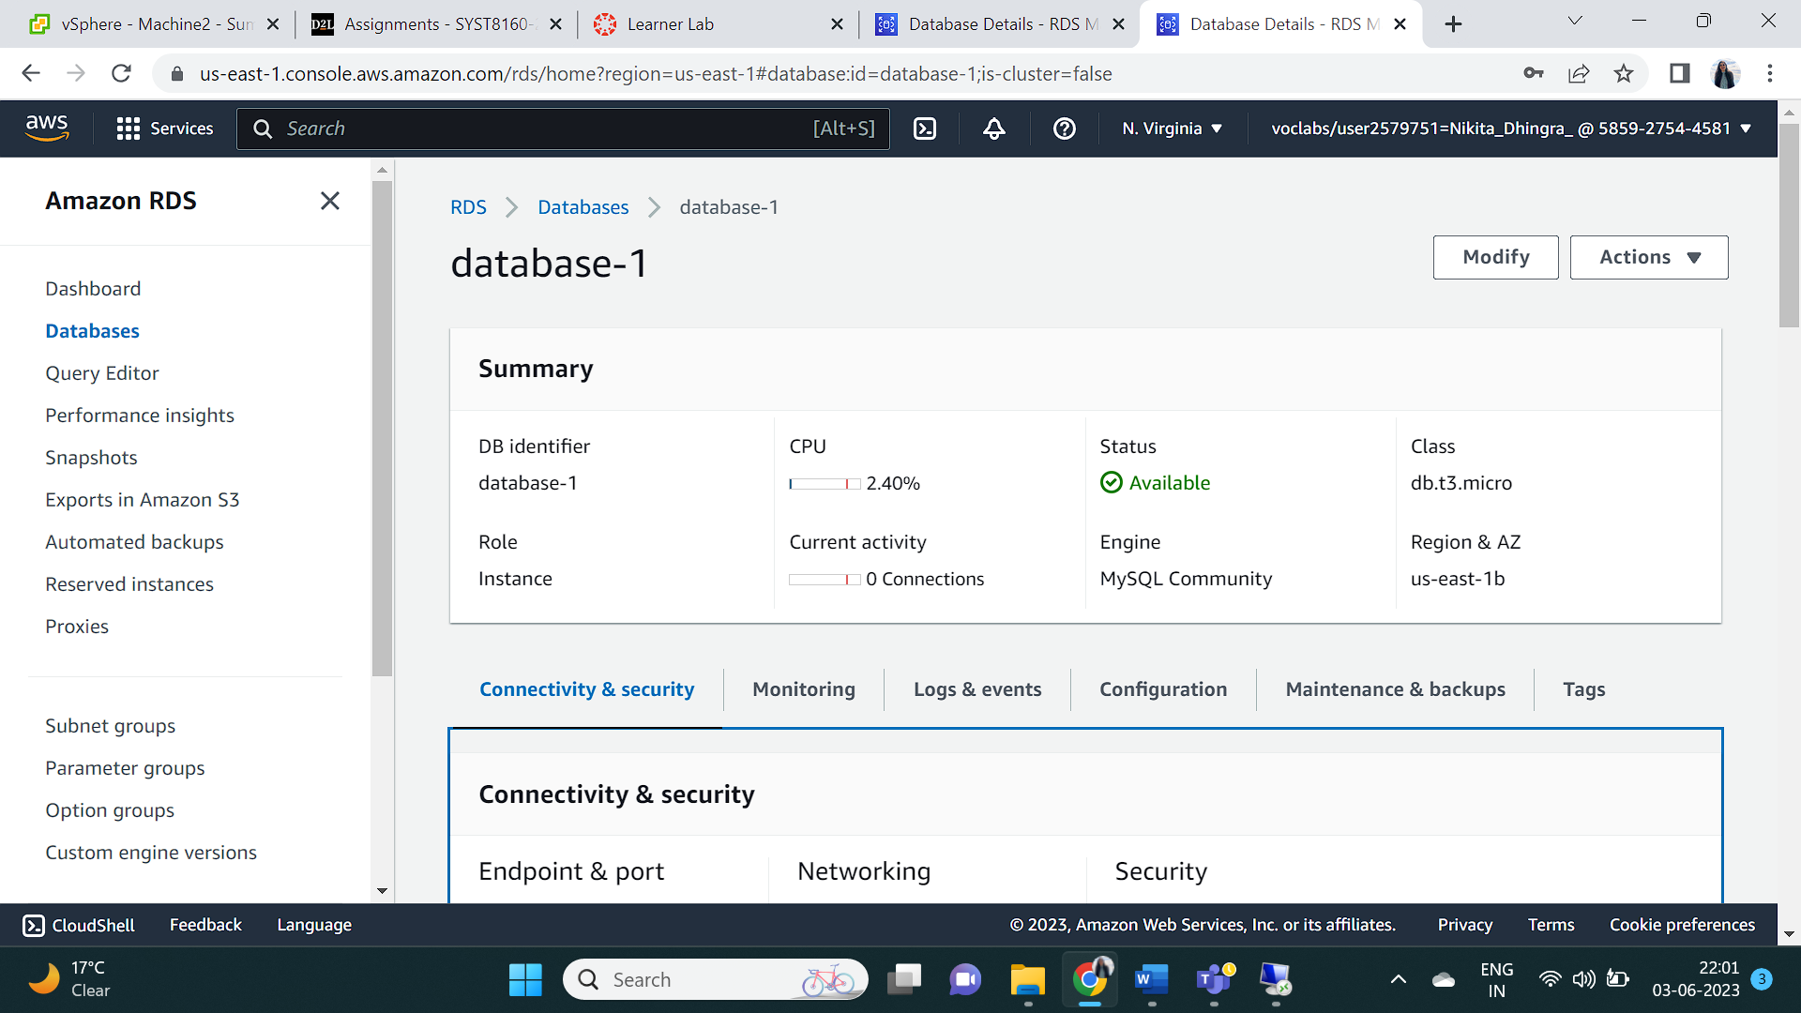

## Reflection

This lab gave knowledge about databases, MySQL Workbench and AWS and successful implementation.